ECS and ECR
ECS: containerization service offered by aws
ECR: like dockerhub

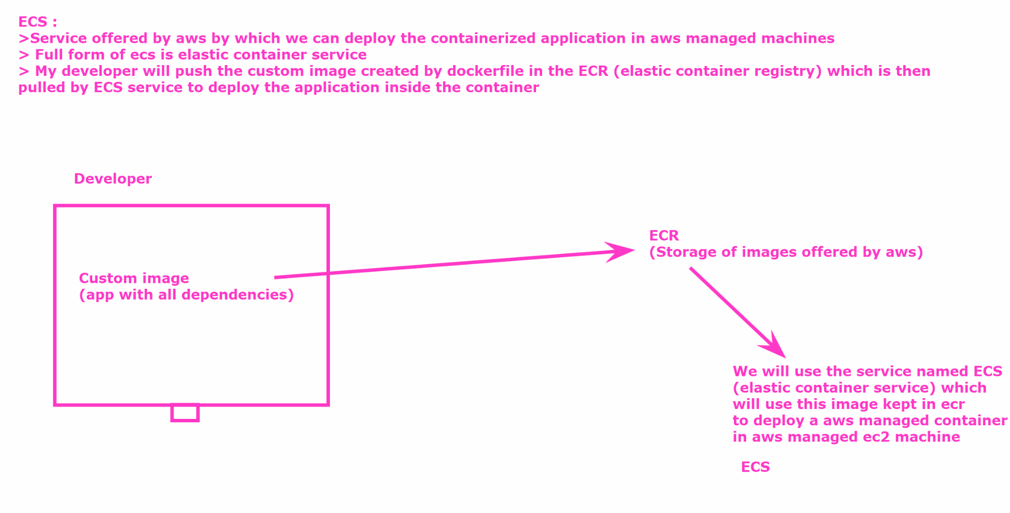

PROJECT : https://github.com/akshu20791/ECS-AWS-LAB

Go in your docker ec2 ubuntu machine

# sudo su

git clone https://github.com/akshu20791/ECS-AWS-LAB

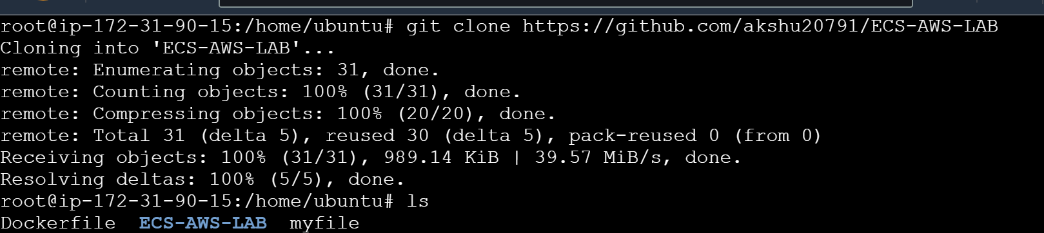
# cd ECS-AWS-LAB (to enter inside the repo which we created)
# ls

In above all the project file is present

WE WILL NOW CREATE ECR (ELASTIC CONTAINER REGISTRY)

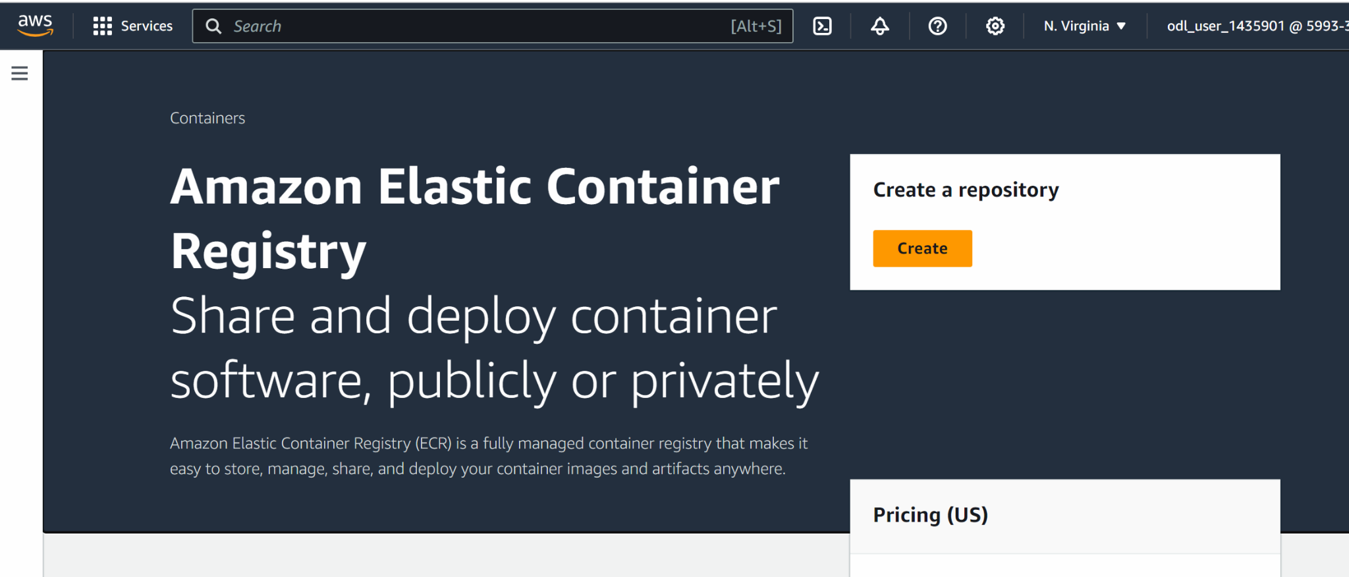

Create

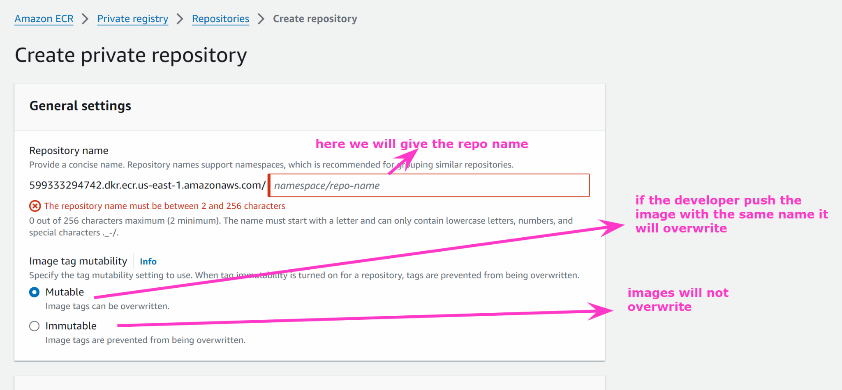

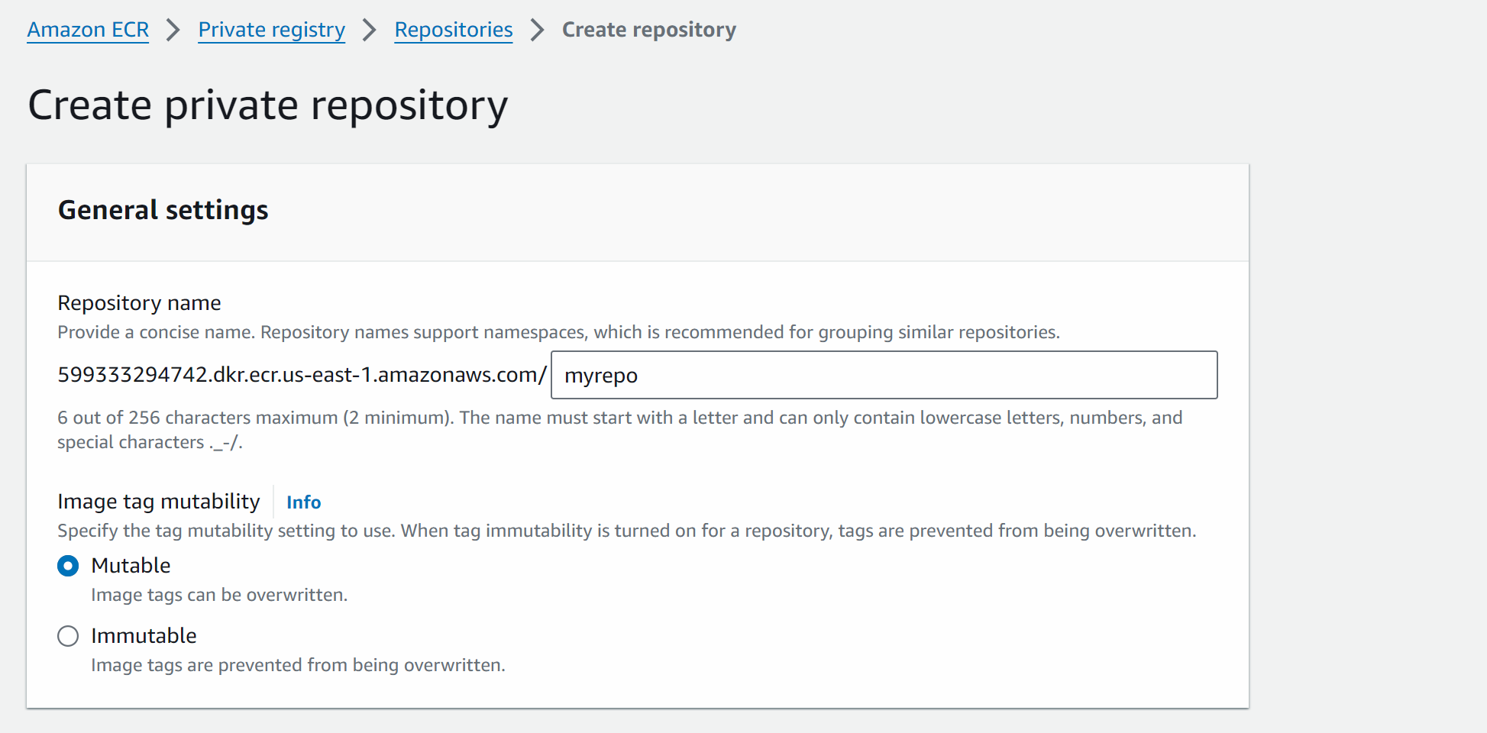

Create

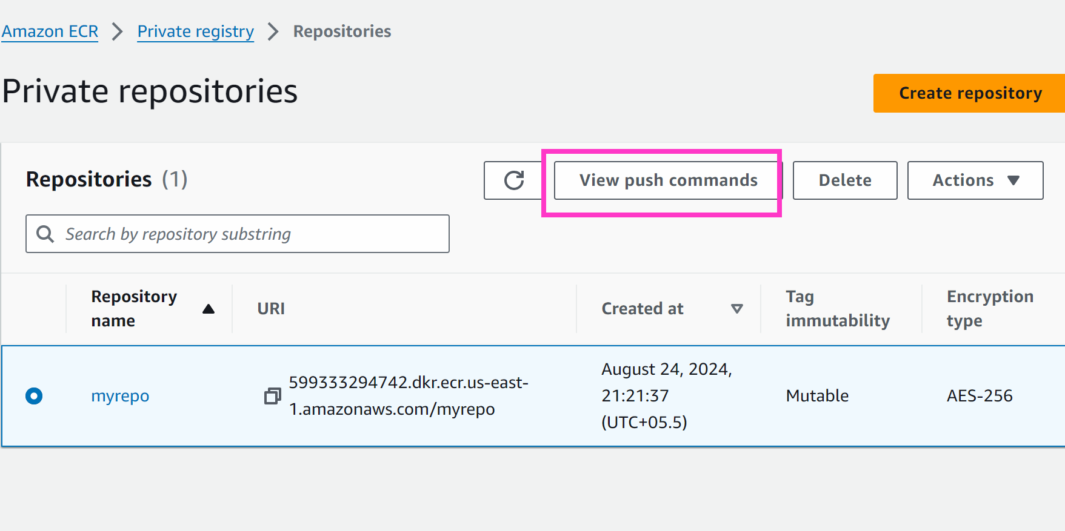

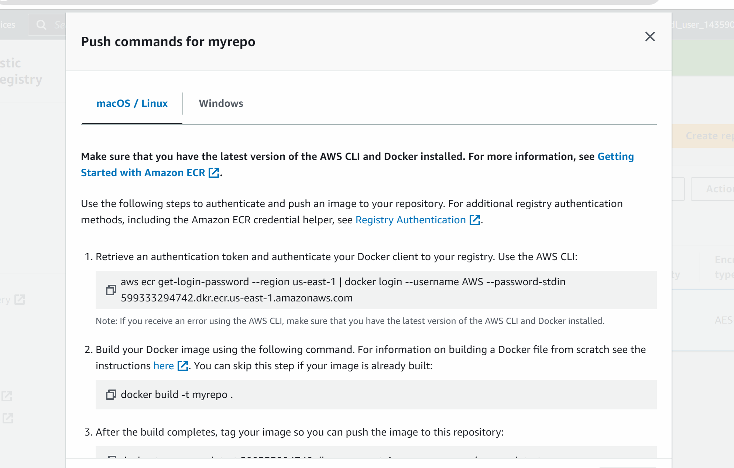

But before entering these commands in the machine we need to use secret key and access secret key to get access of aws account from the machine

To generate access key and secret access key 👍

Go to iam -> go to user which is already created for you
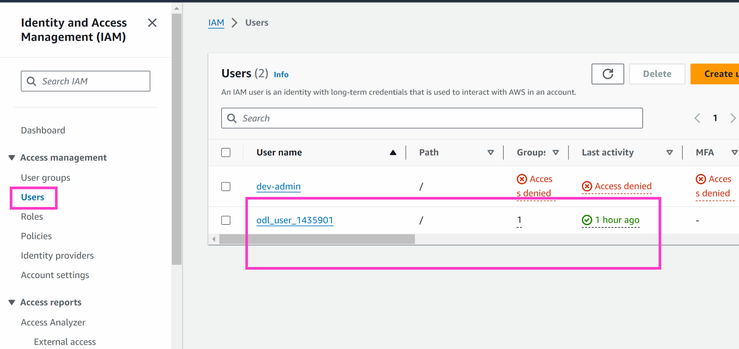

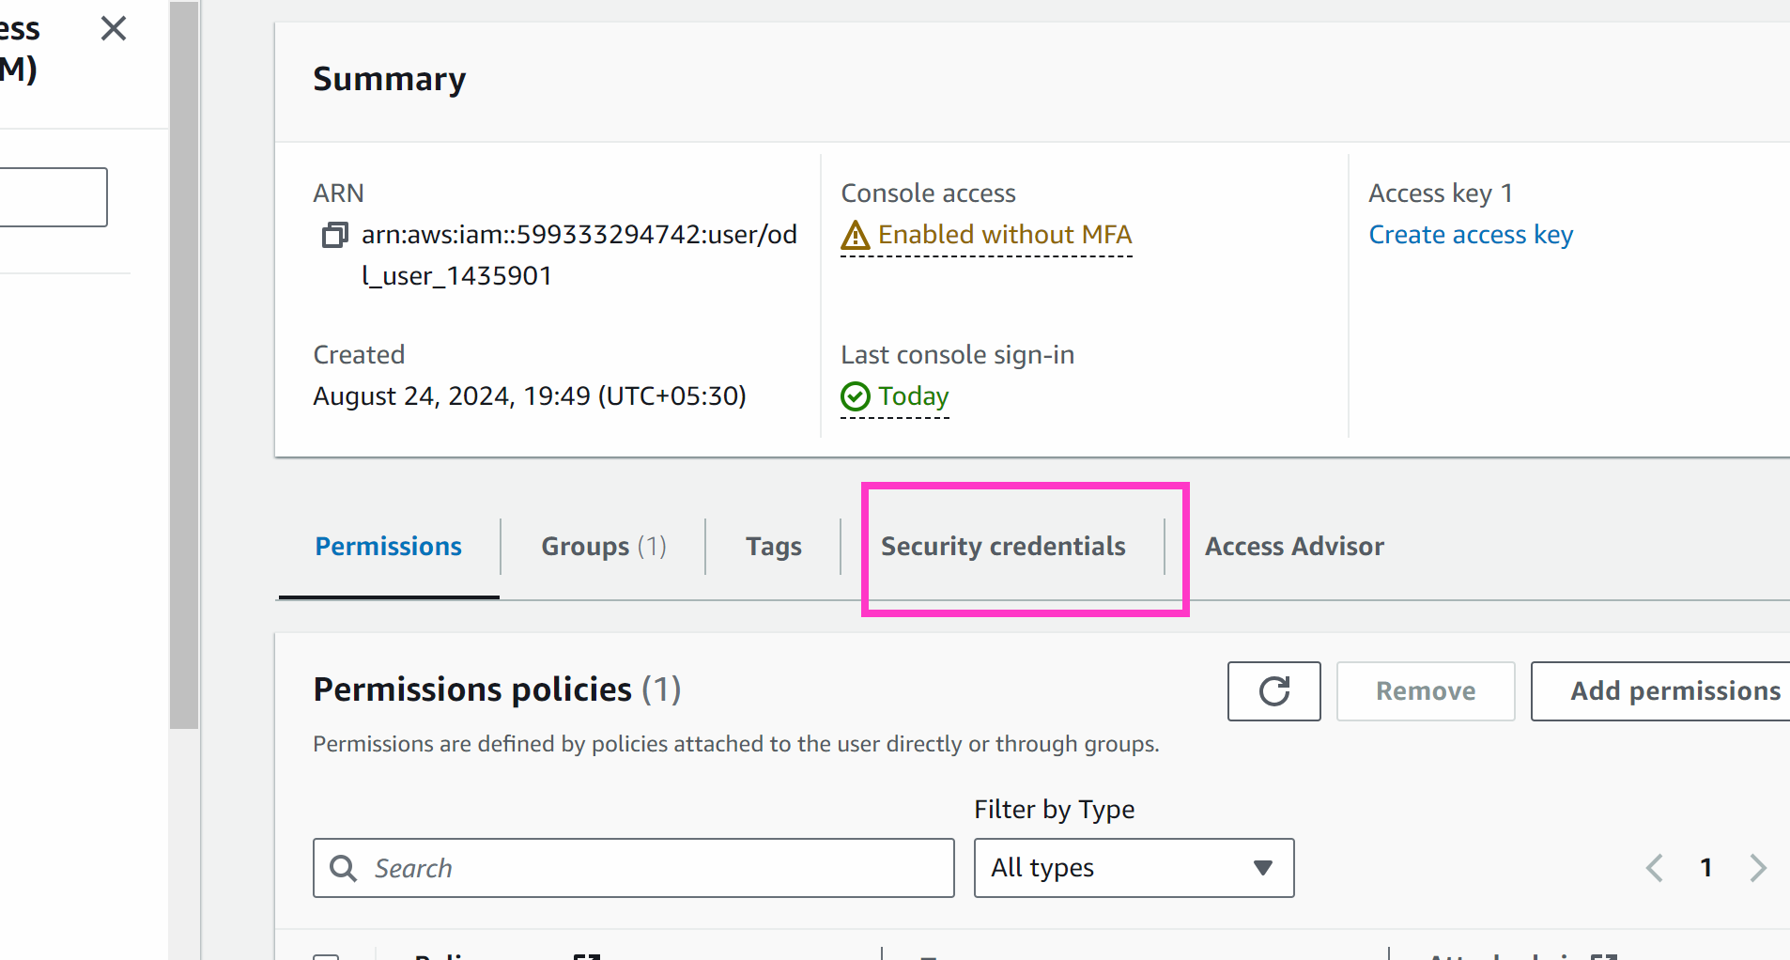

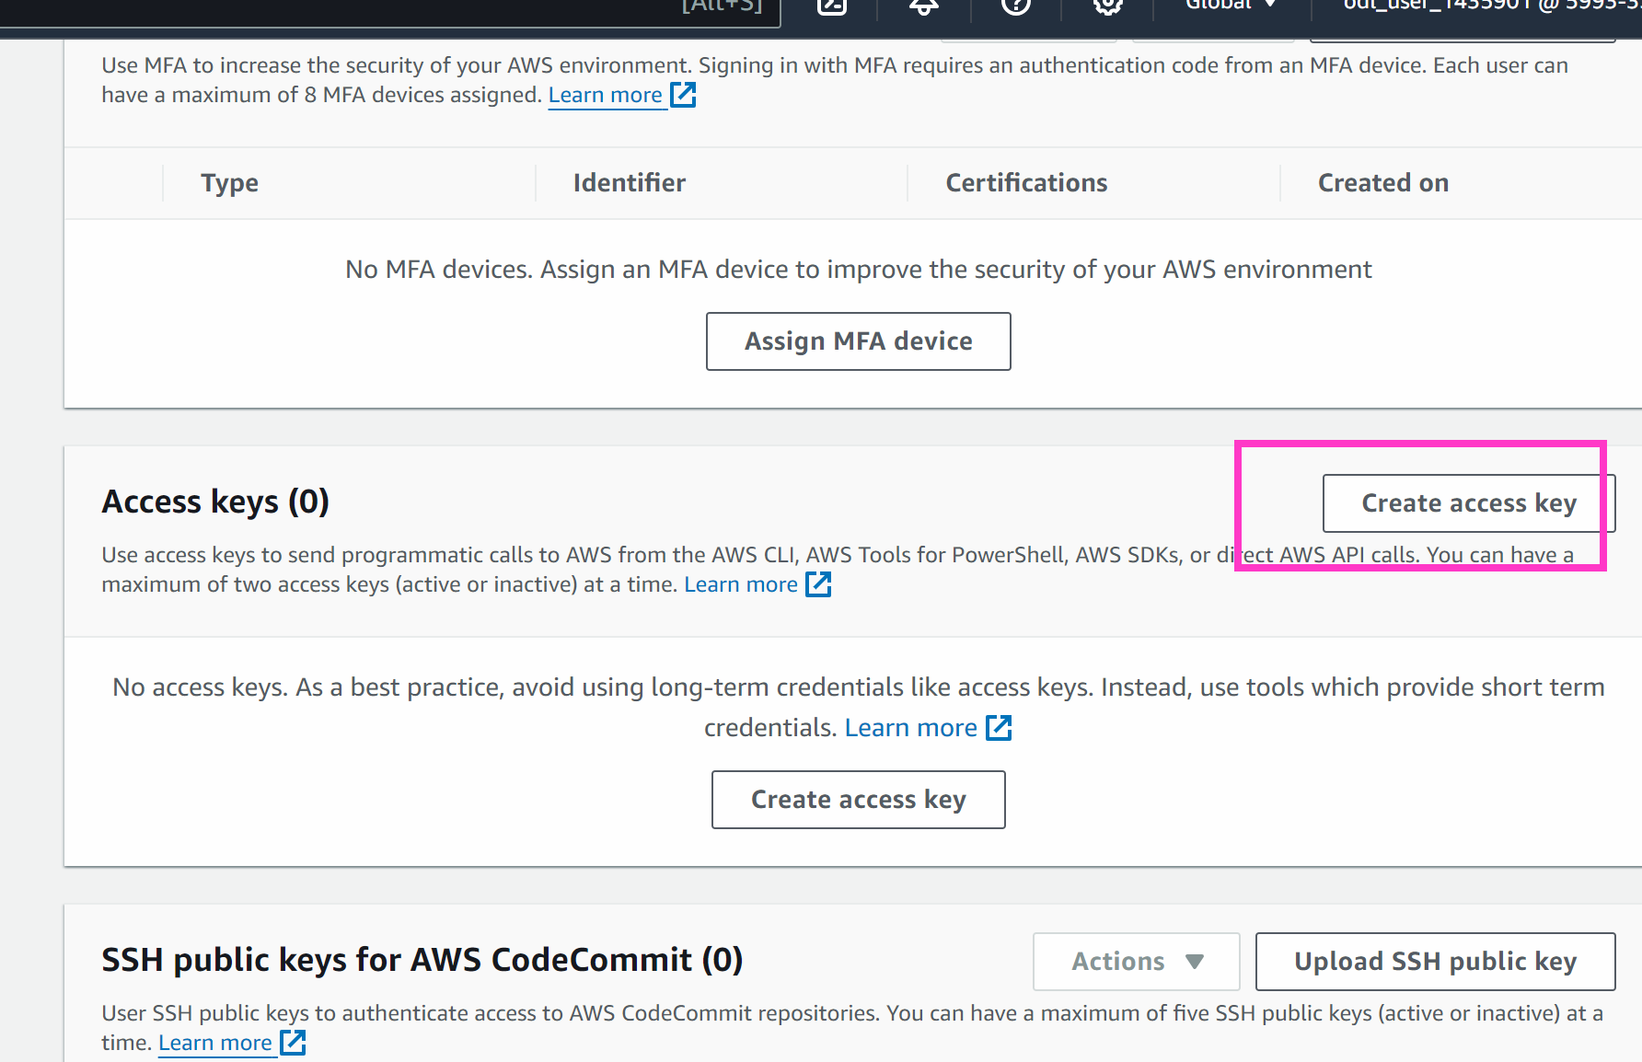

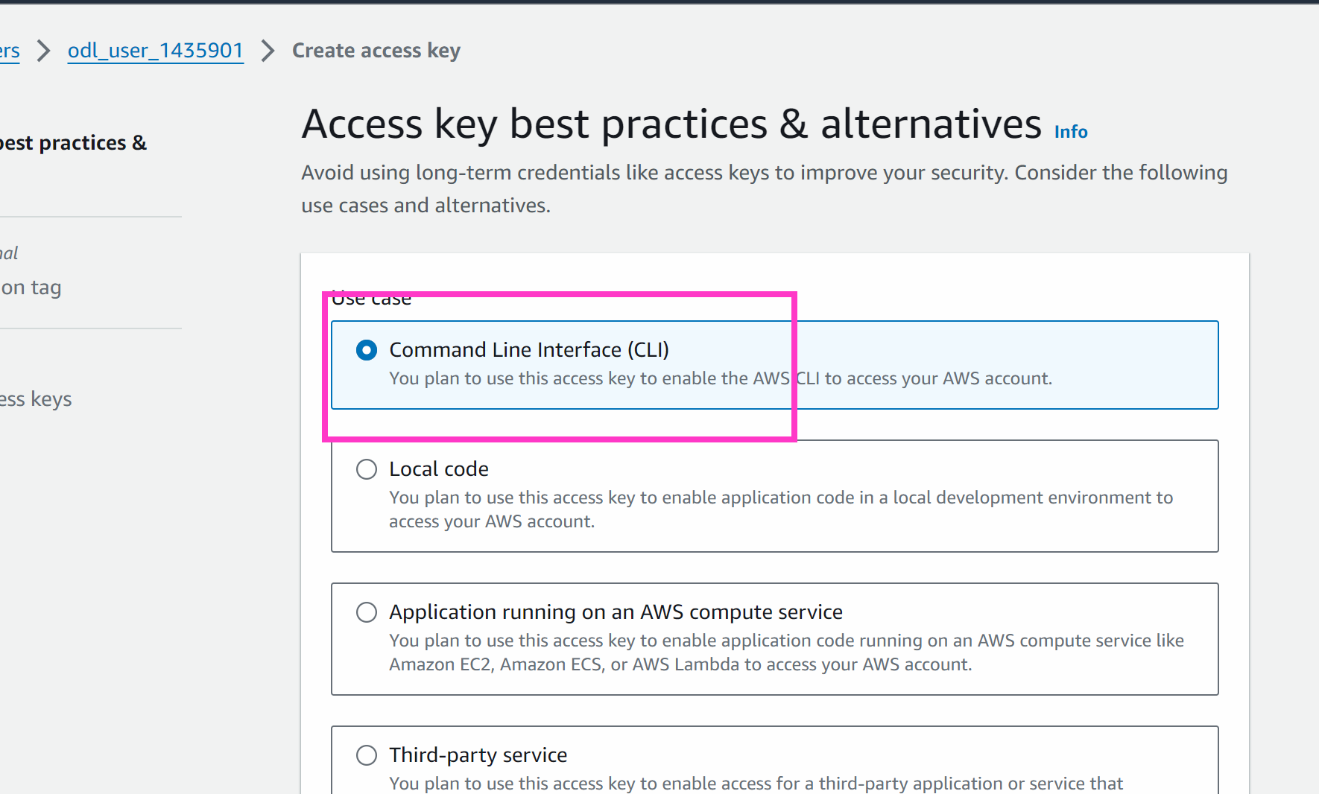

Next

Create access keys

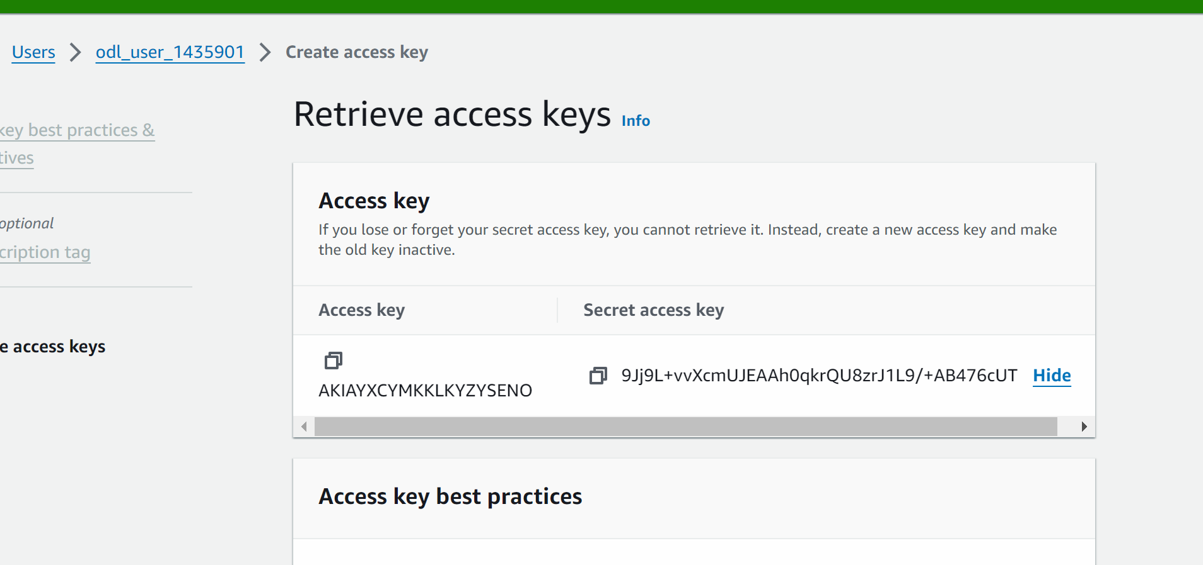

Now copy the access key

Go to your ec2 machine

curl "https://awscli.amazonaws.com/awscli-exe-linux-x86_64.zip" -o "awscliv2.zip"
apt install unzip -y
unzip awscliv2.zip
sudo ./aws/install

aws configure

# it will ask for accesskey and secret access key which we can copy
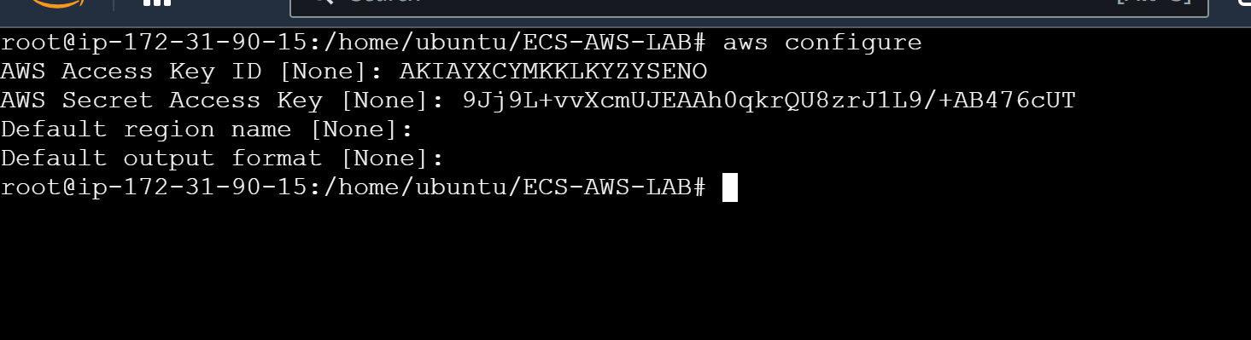

Installing docker
# apt update
# apt install docker.io -y

Now we will go to ECR

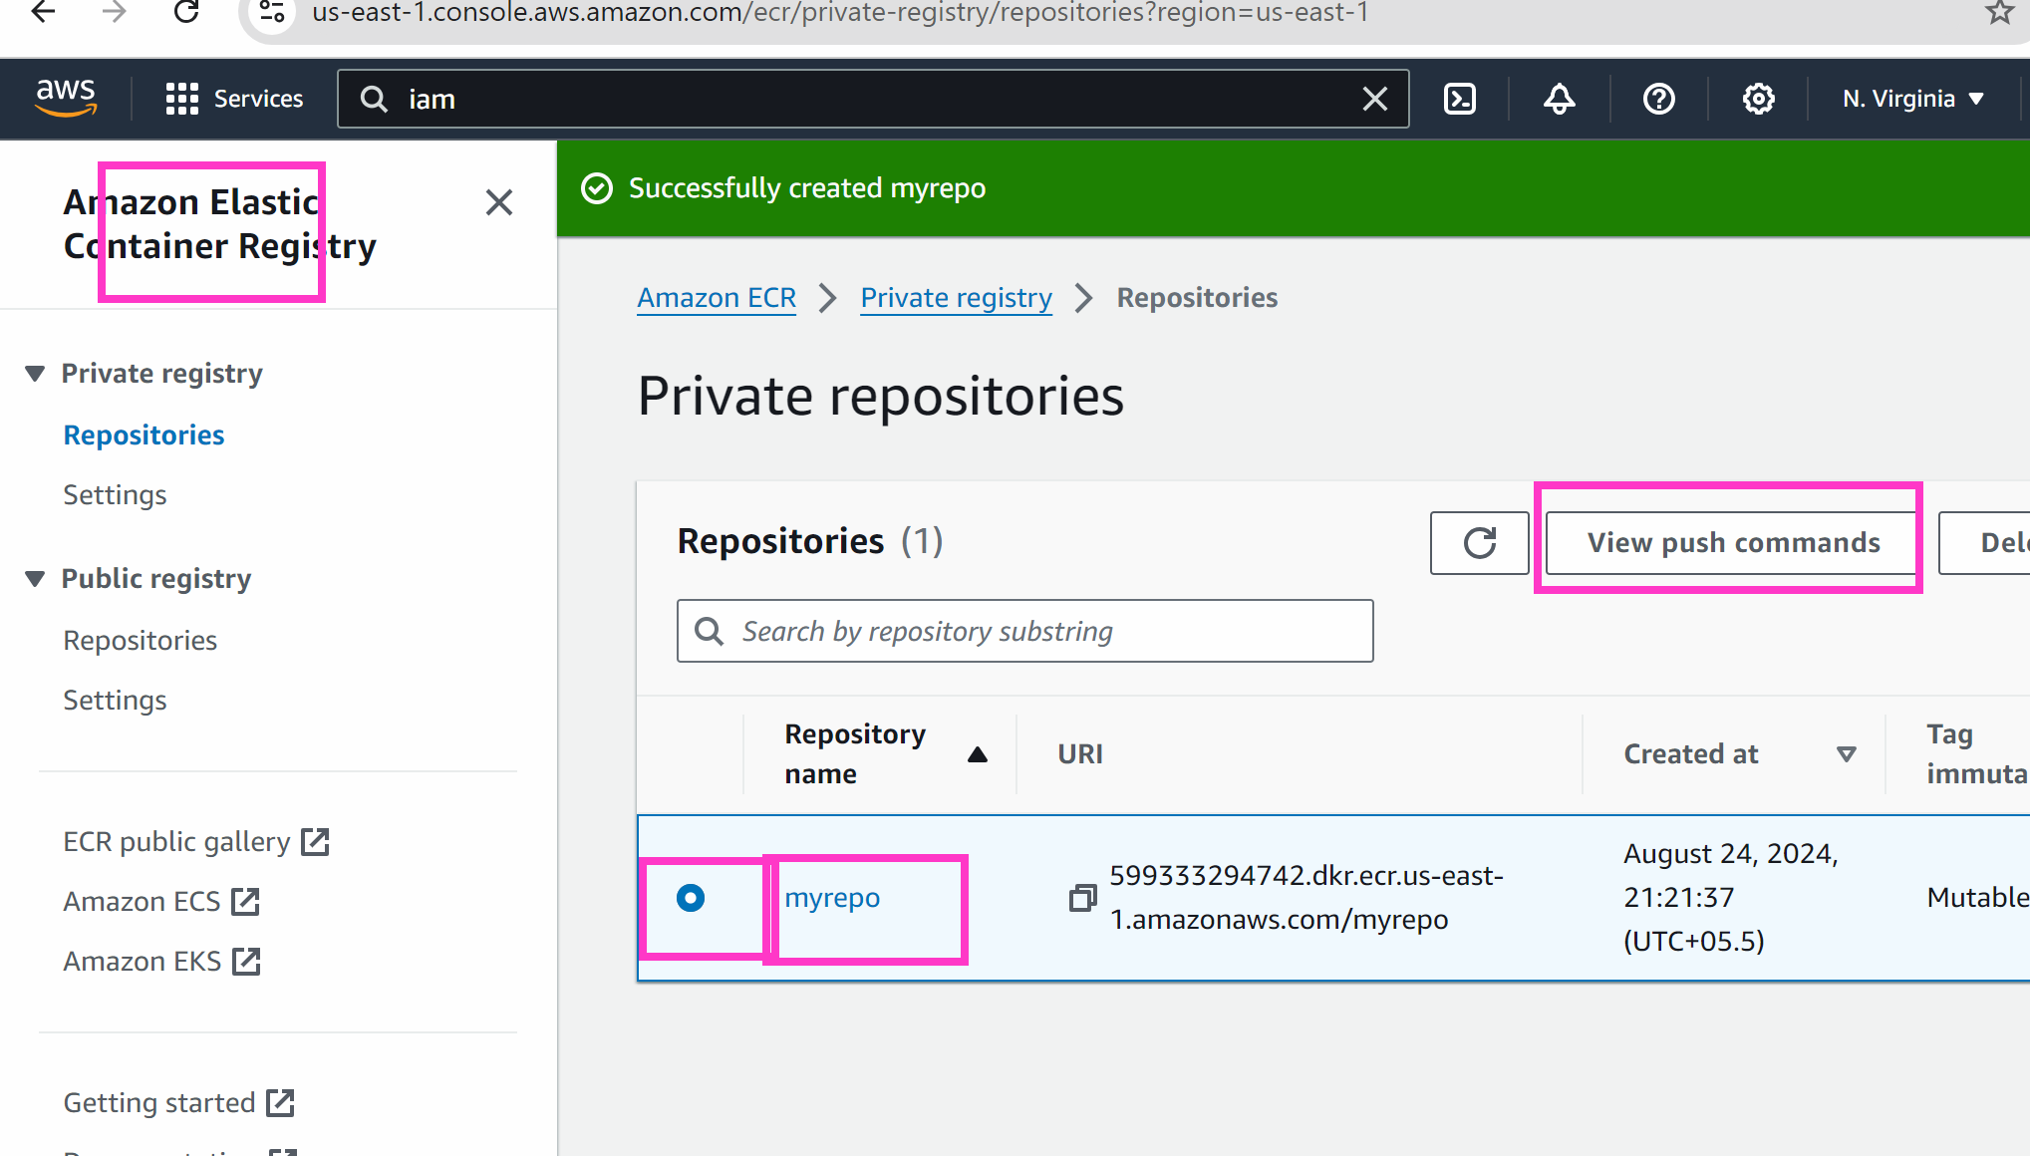

Copy the below commands one by one in your machine

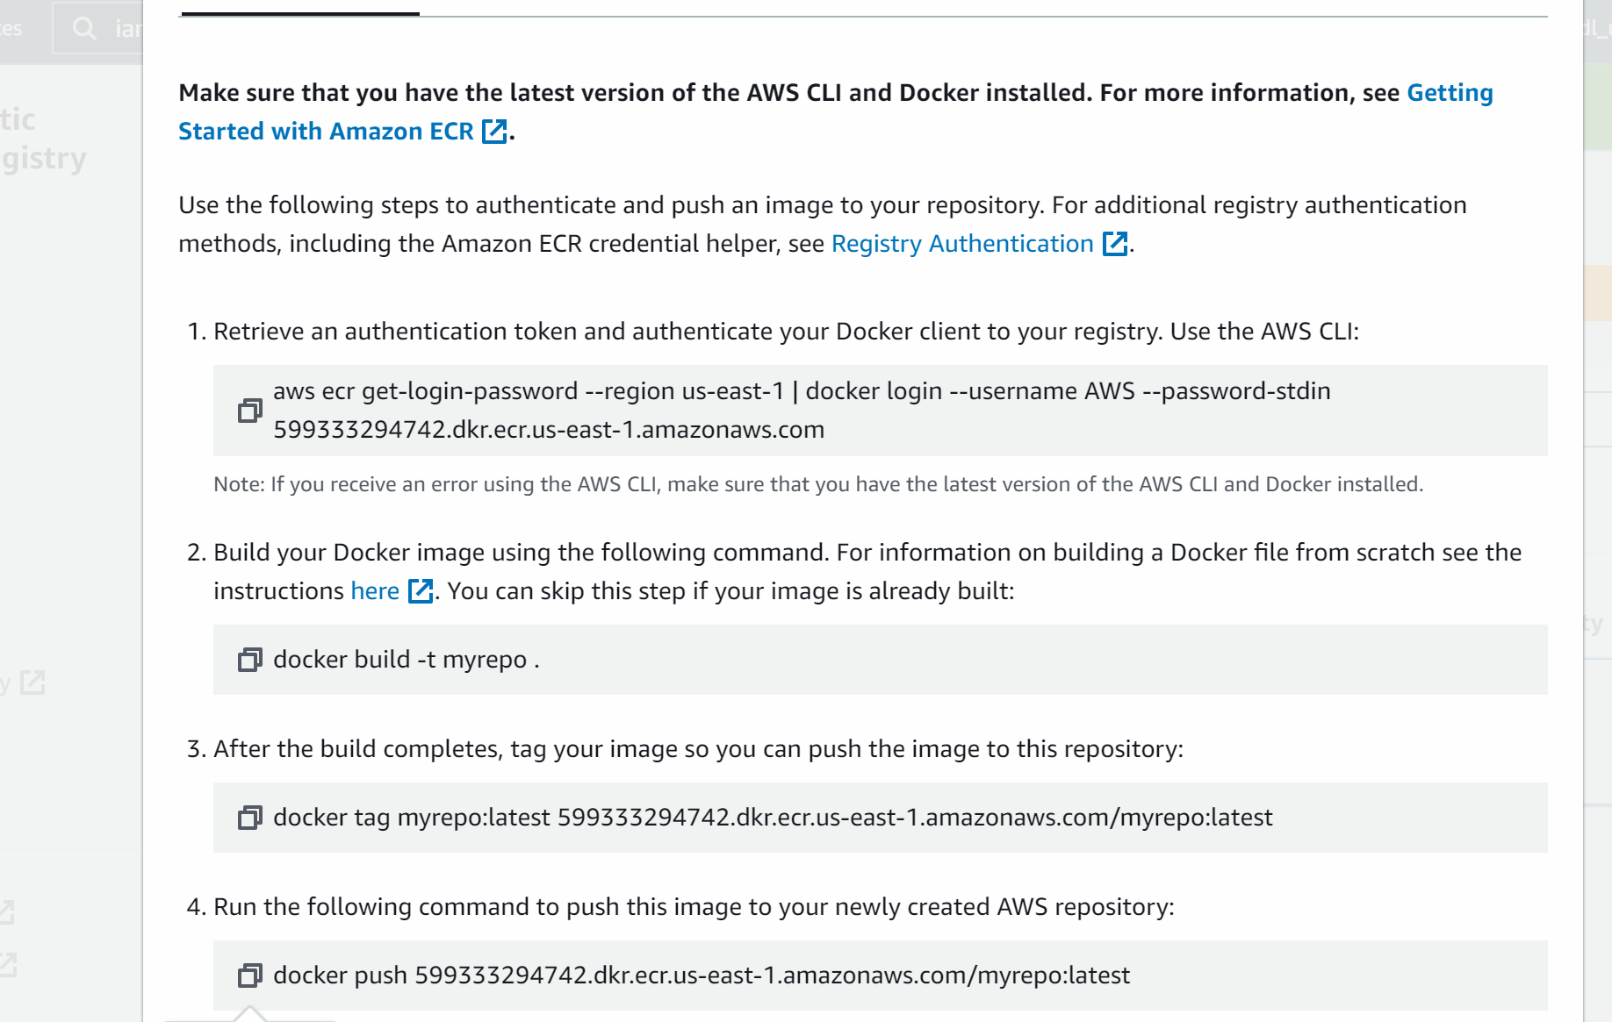

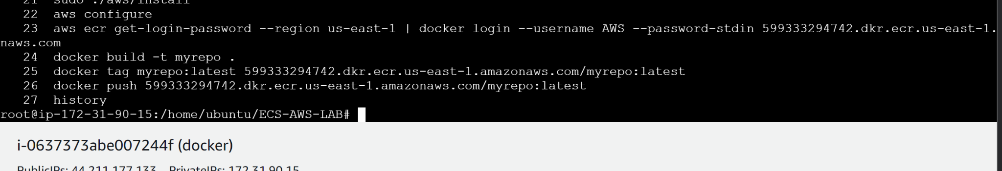

###############

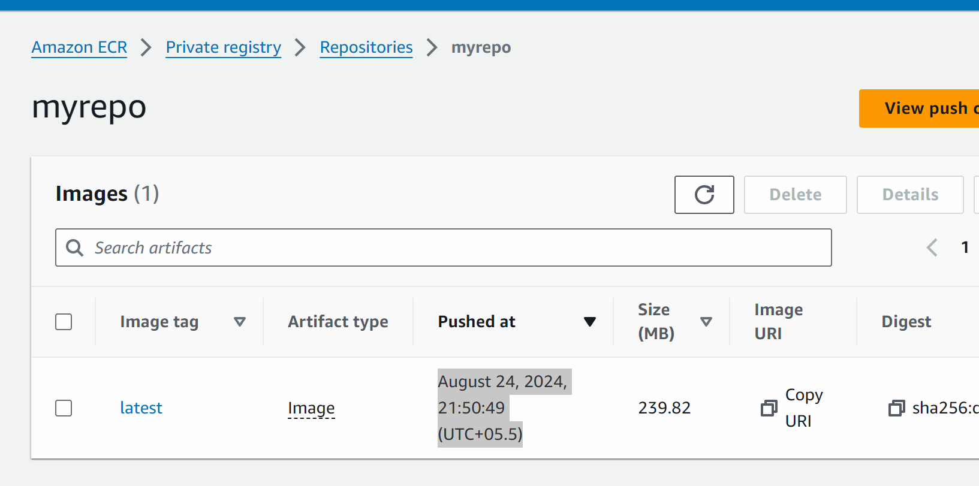

We have pushed the image on ecr which should be used by ecs to create a continainer with custom image

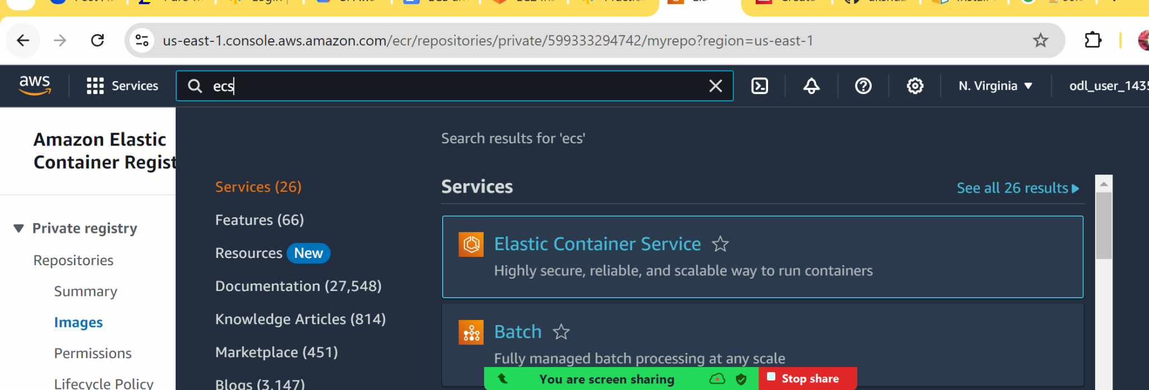

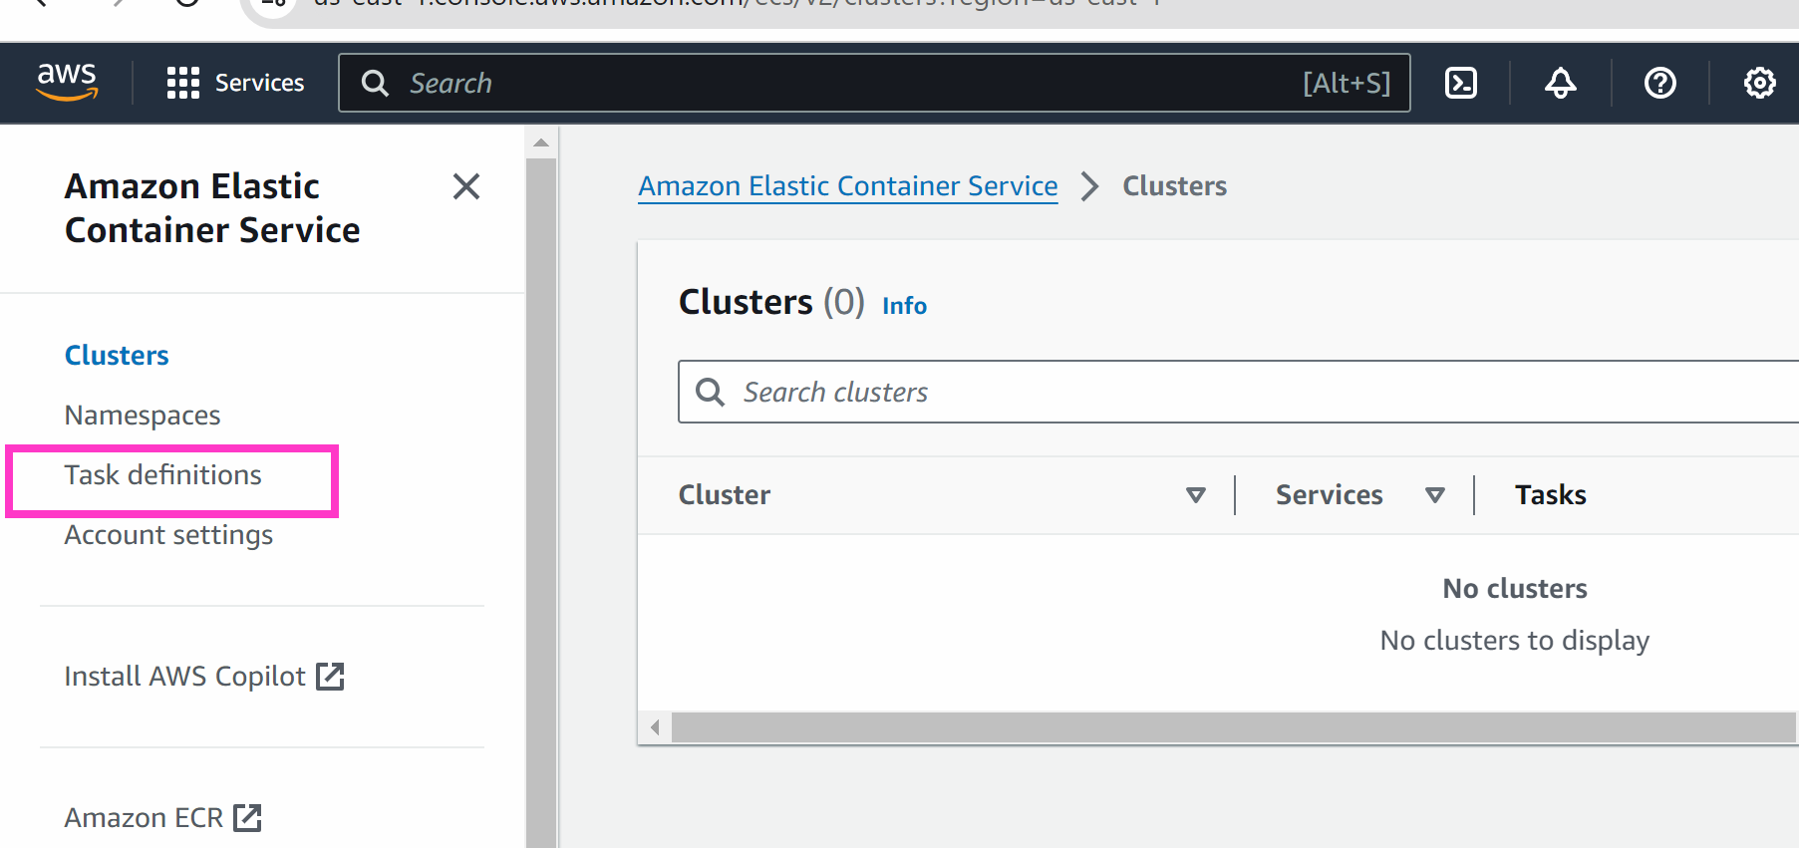

Create a new task definition

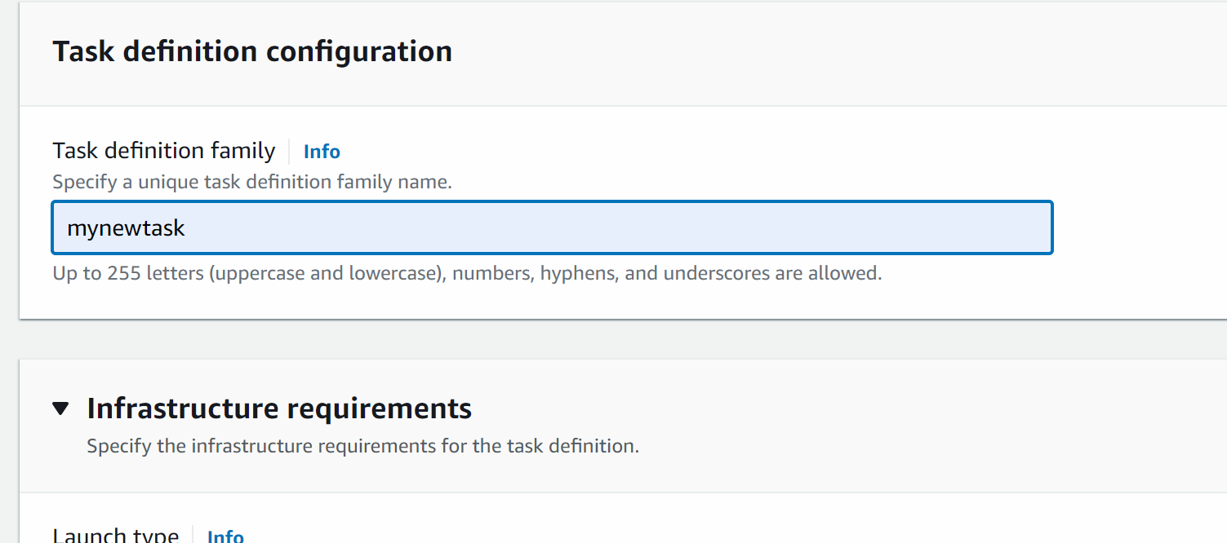

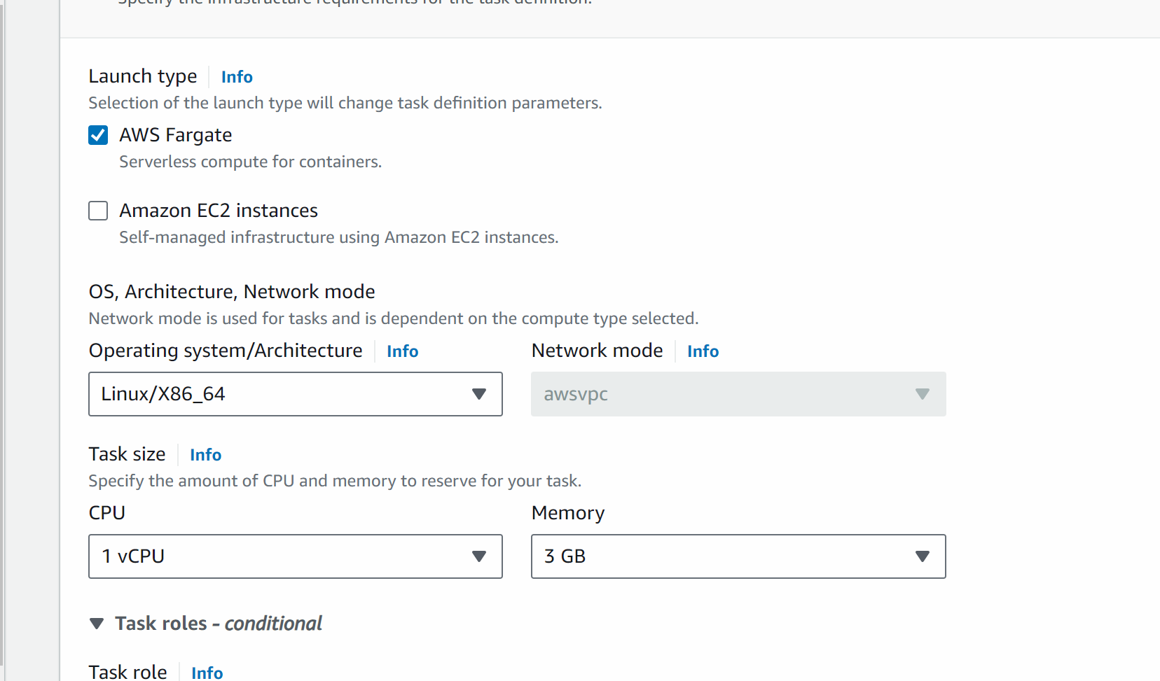

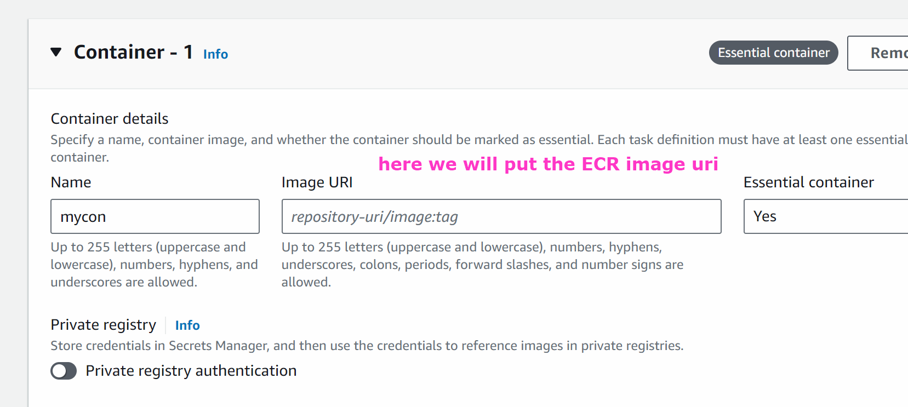
Put port as 8080

Open ecr in new tab and copy the image

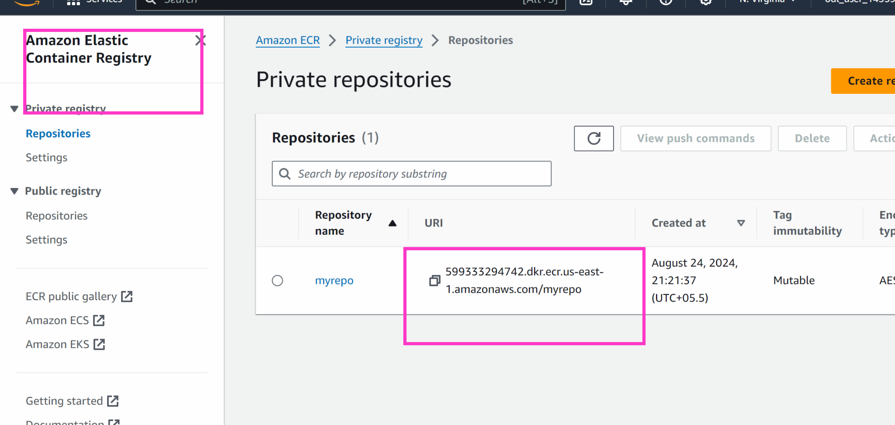

Go back to ecs task definition

And paste the image uri

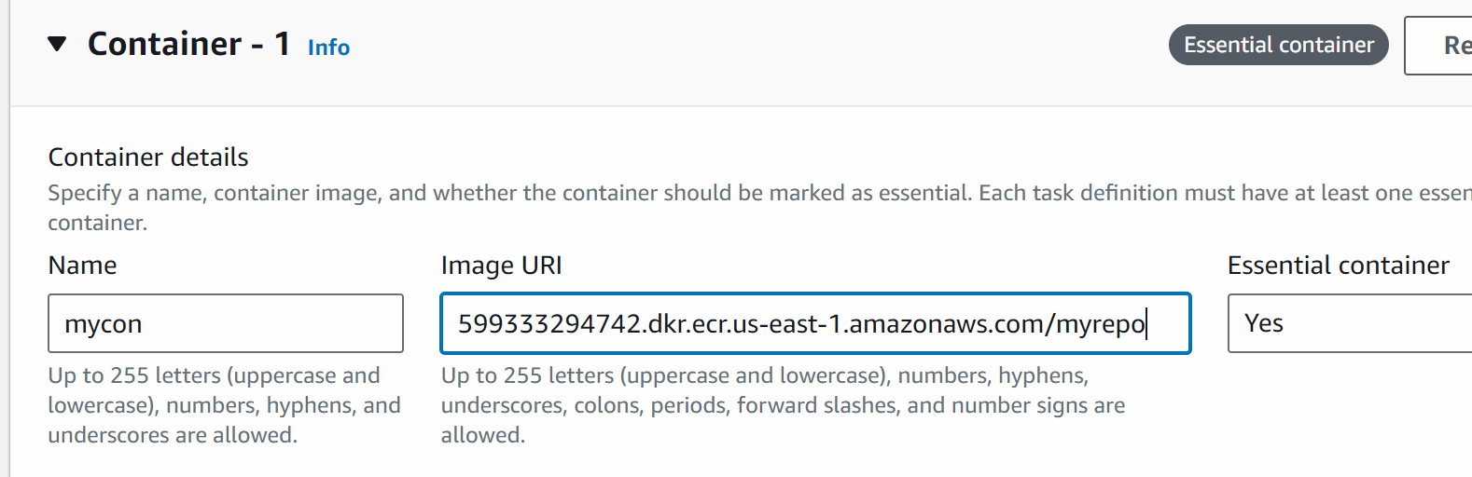
Select container port as 8080

Scroll down and create task definition

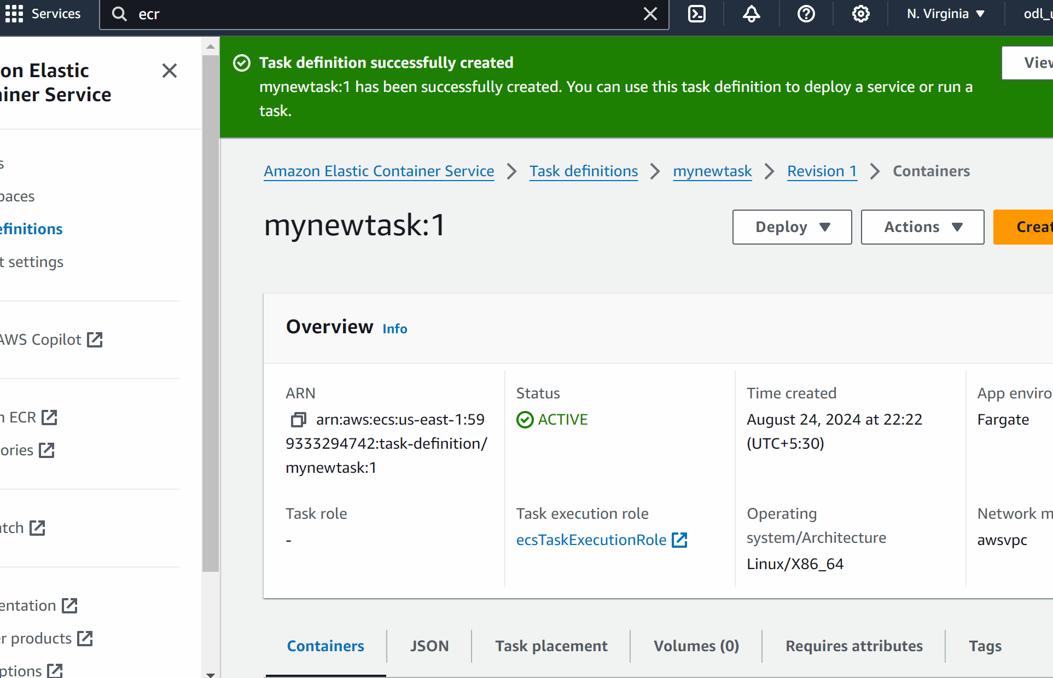

#### Now we will do and create the ECS cluster

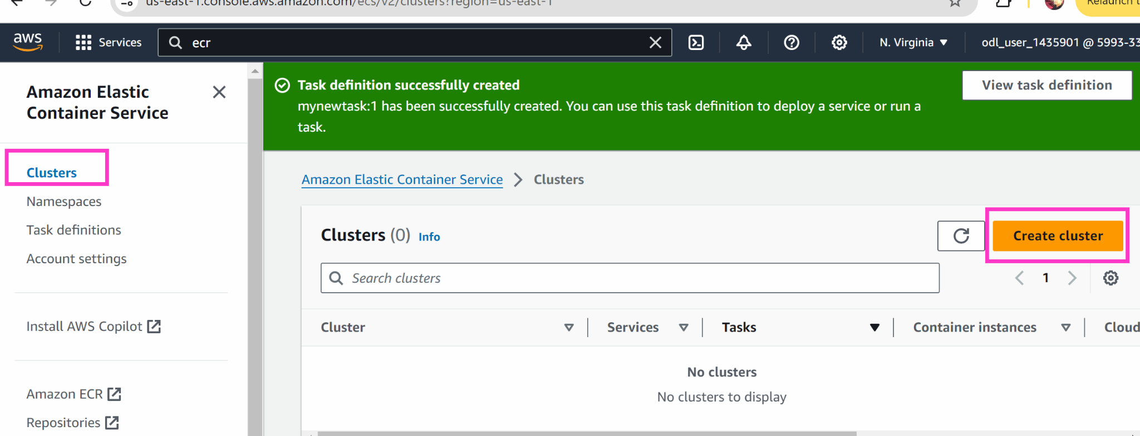

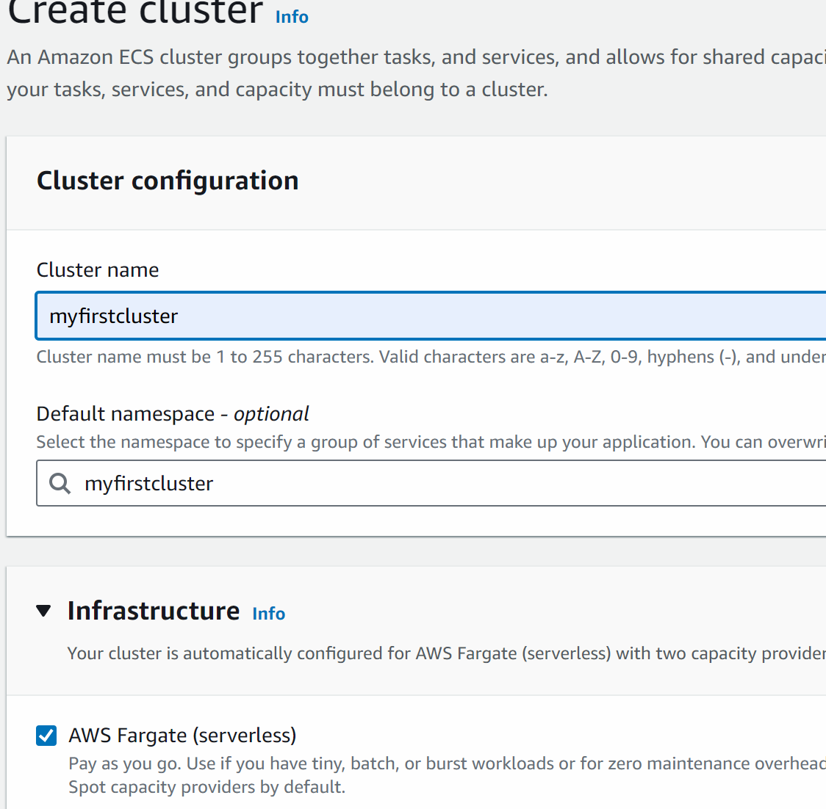

Create

# if error comes up create cluster again with different name
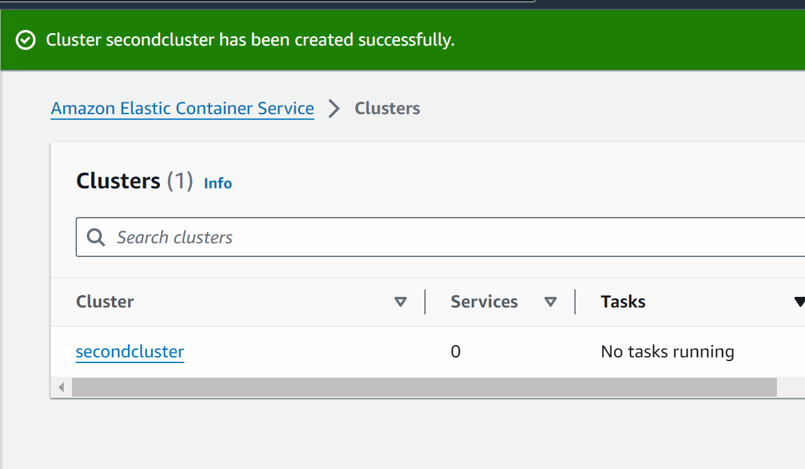

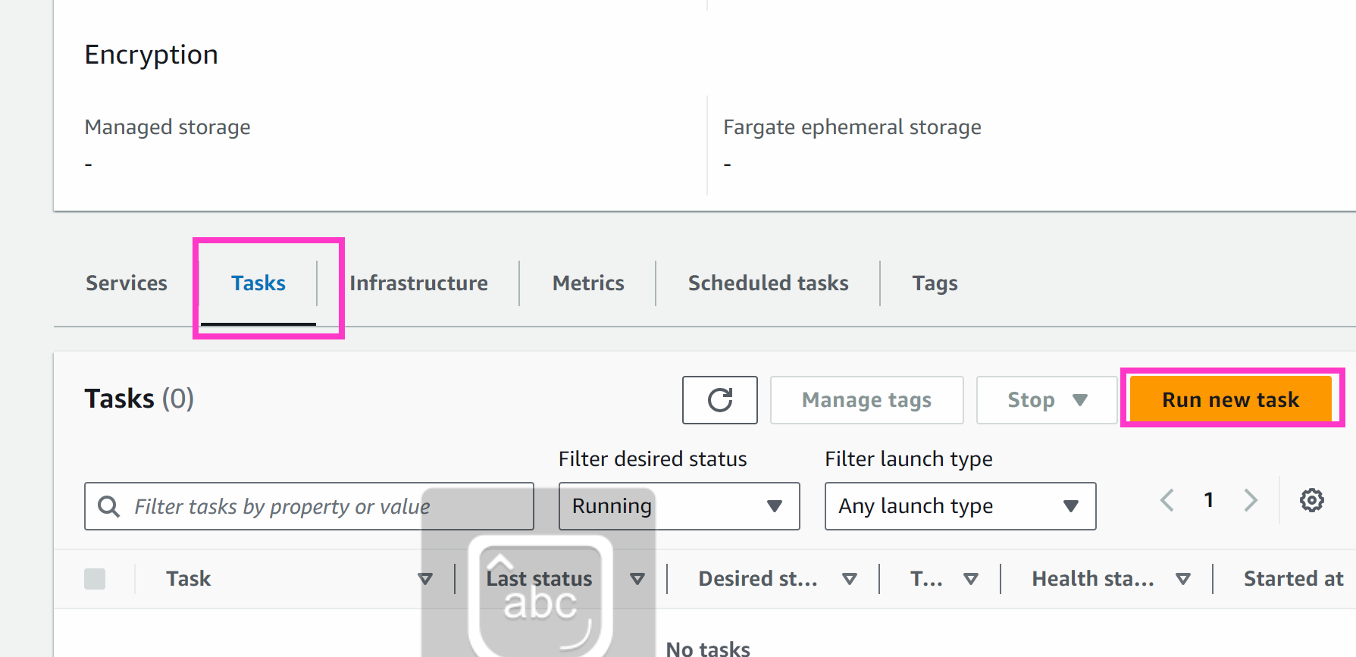

Task : inside infra we want to deploy the container

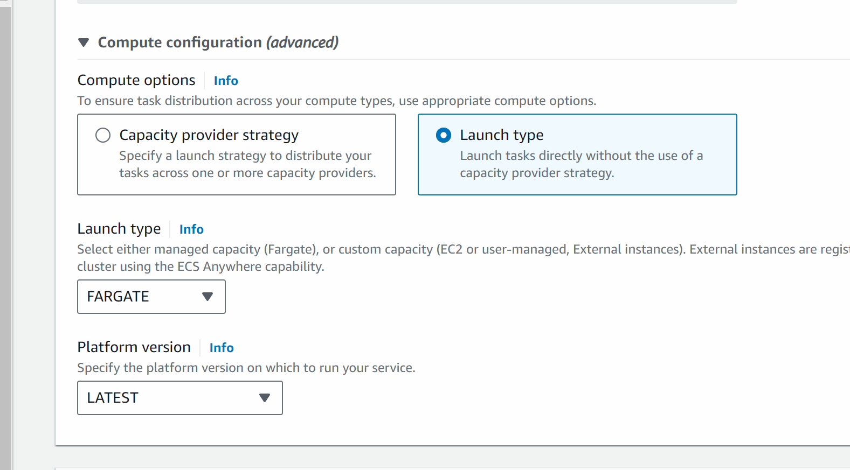

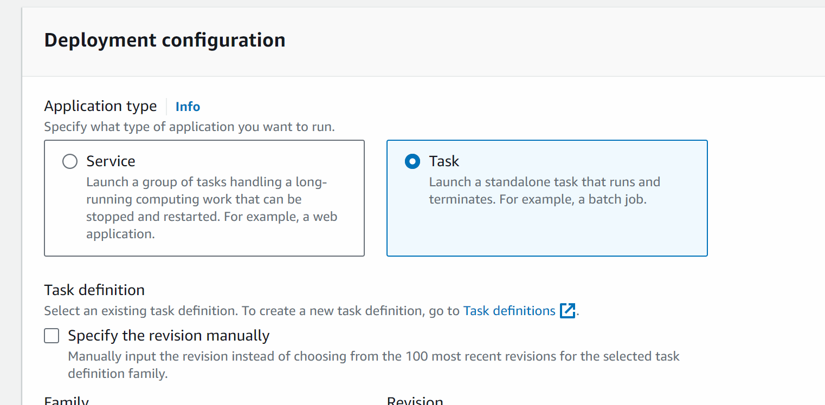

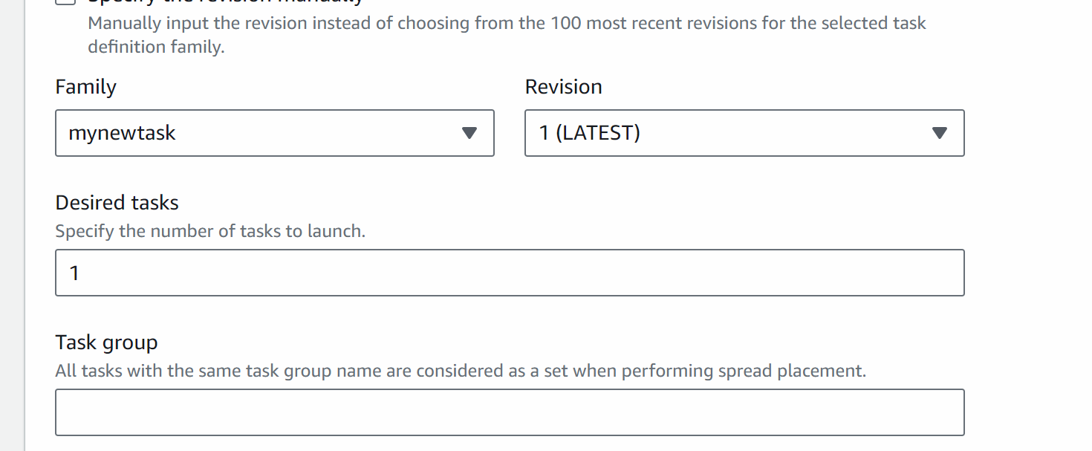

Click on networking

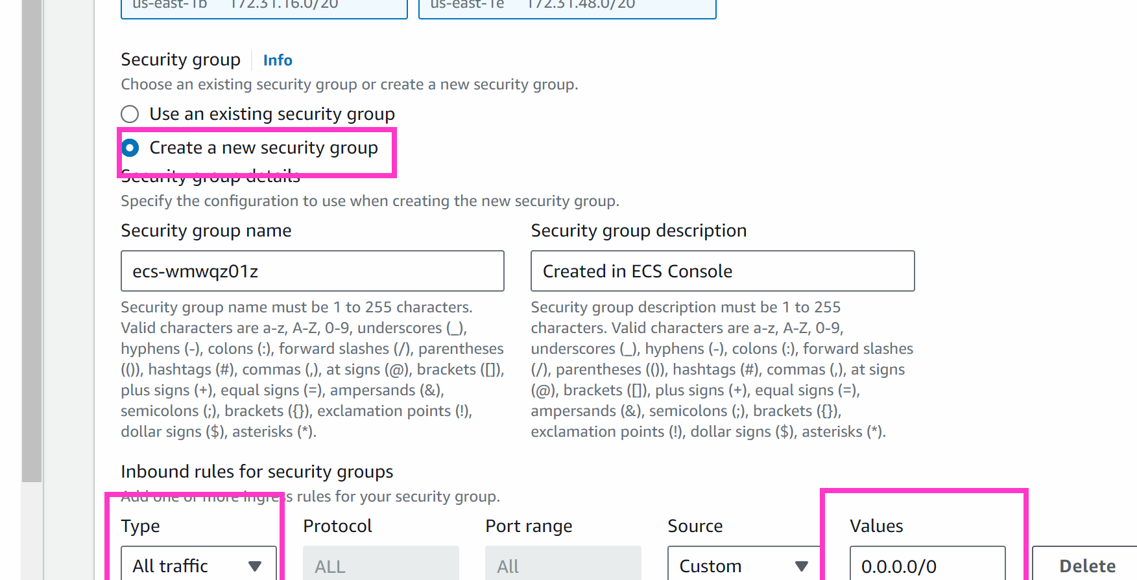

Create

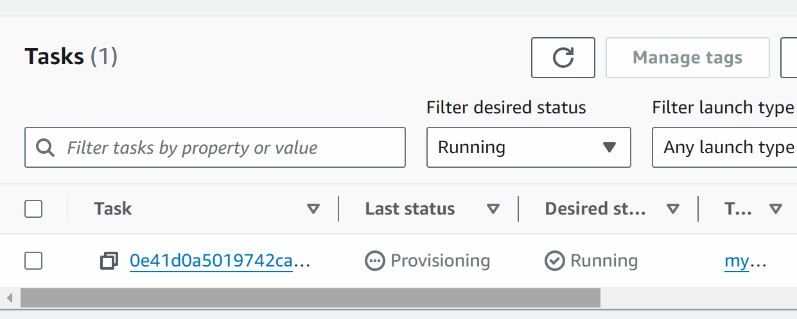

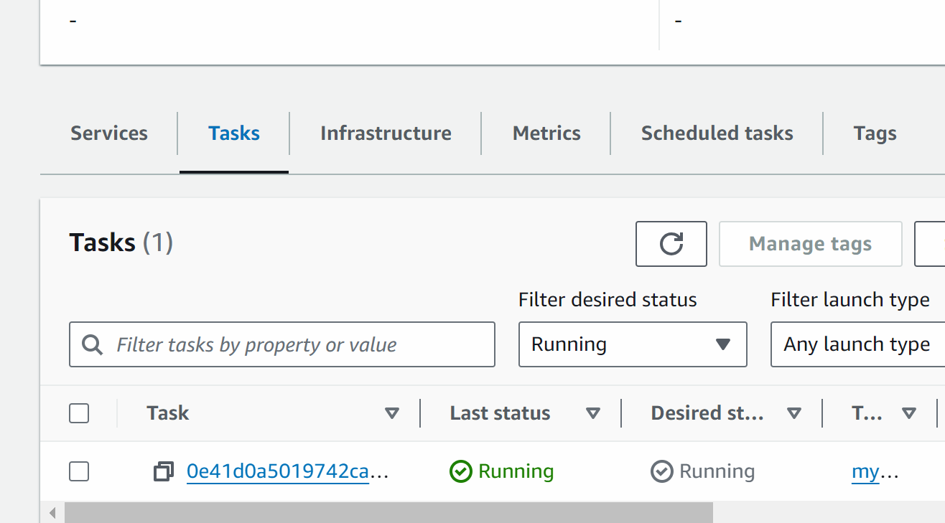

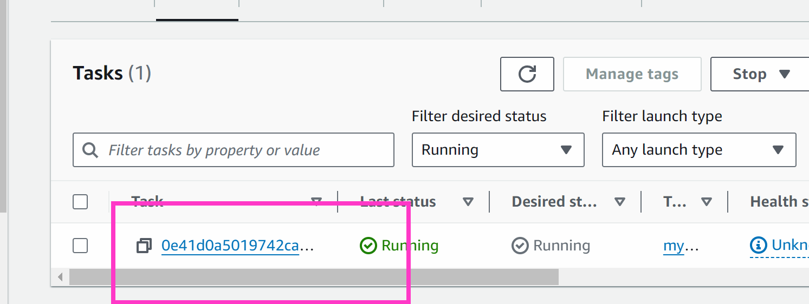

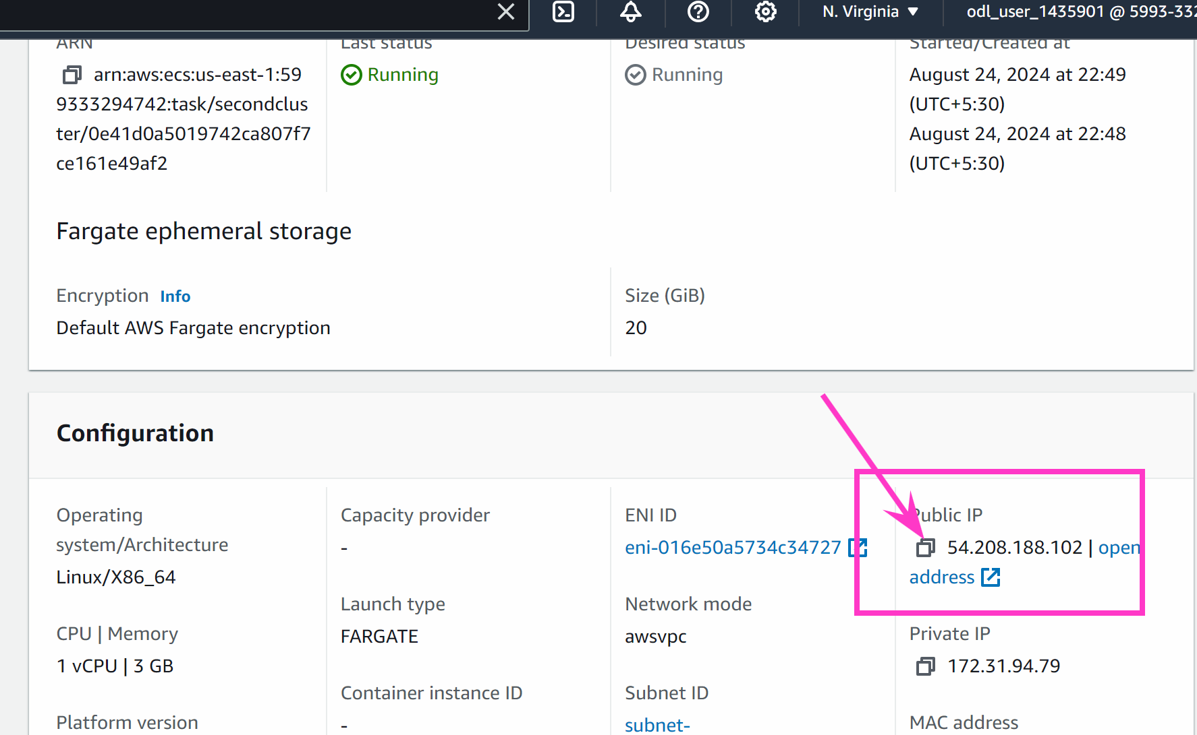

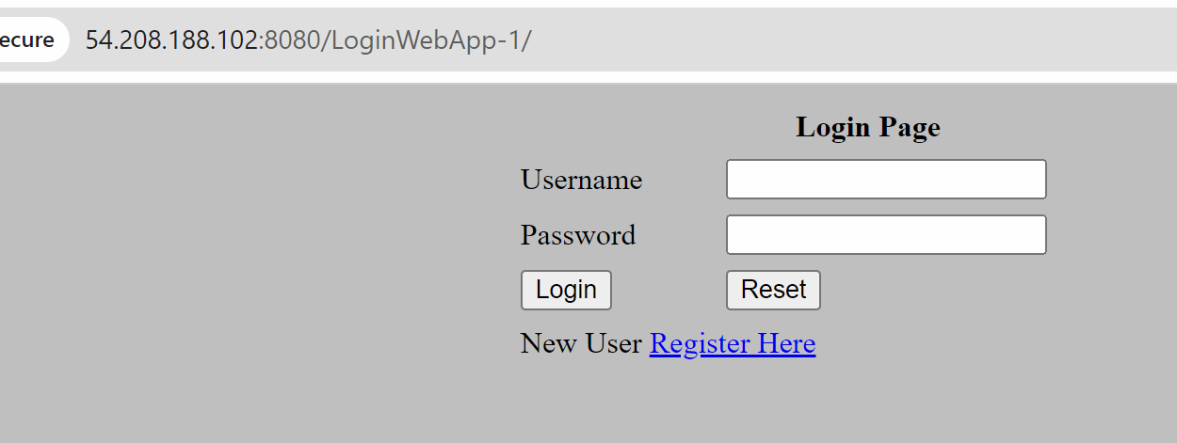

http://54.208.188.102:8080/LoginWebApp-1/

### So delete the tasks
And lets create a service(we will create after loadblancer) ….service creates and manages n number of tasks together
But the all the tasks will have its own ip address and if the tasks is stopped or restarted or scaling happen a ip address is assigned….if need a fixed endpoint …here we will create a loadbalancer

Go to ec2

Go to load balaner -> Create target group
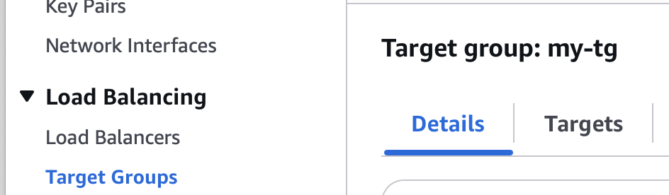

Select ip addresses
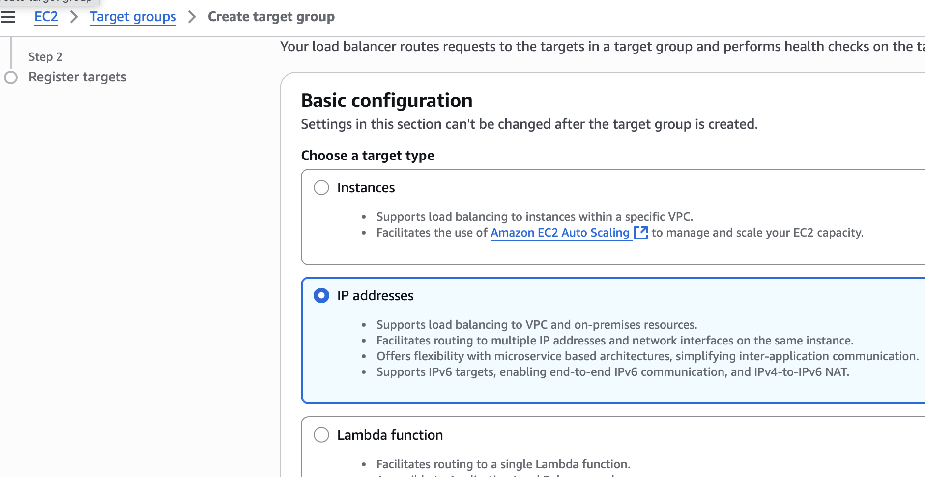

Give target group some name
Port : 8080
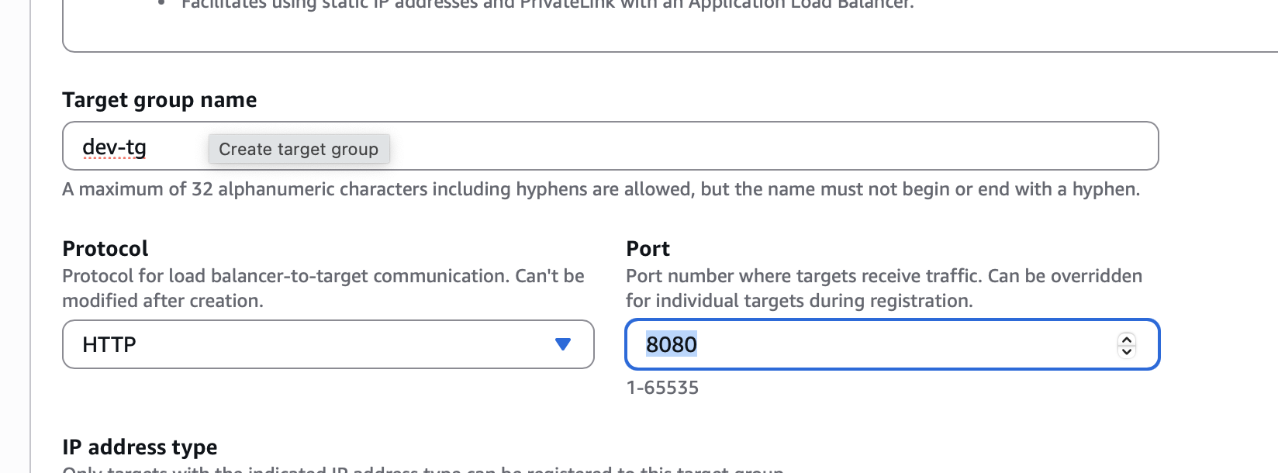

In health check put /LoginWebApp-1/
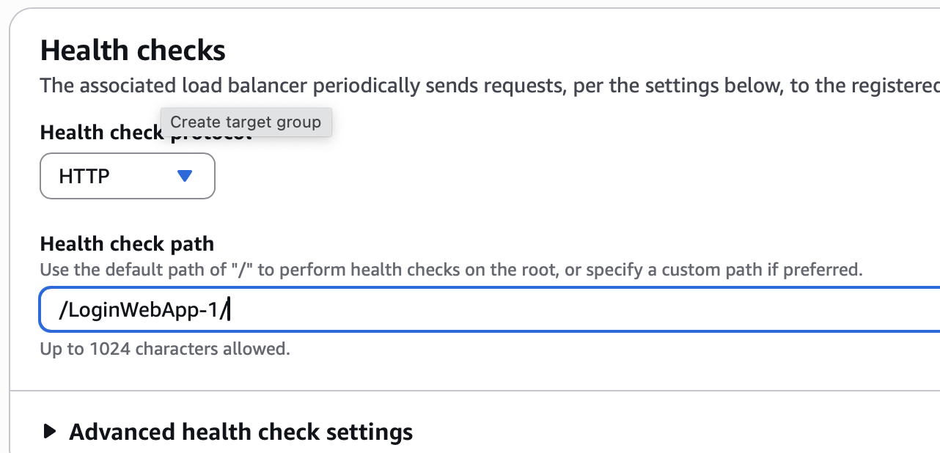
Next

Do not add anything as pending below
Create a target group

NOW LETS CREATE A LOAD BALANCER

Go to loadbalancer -> create application lb
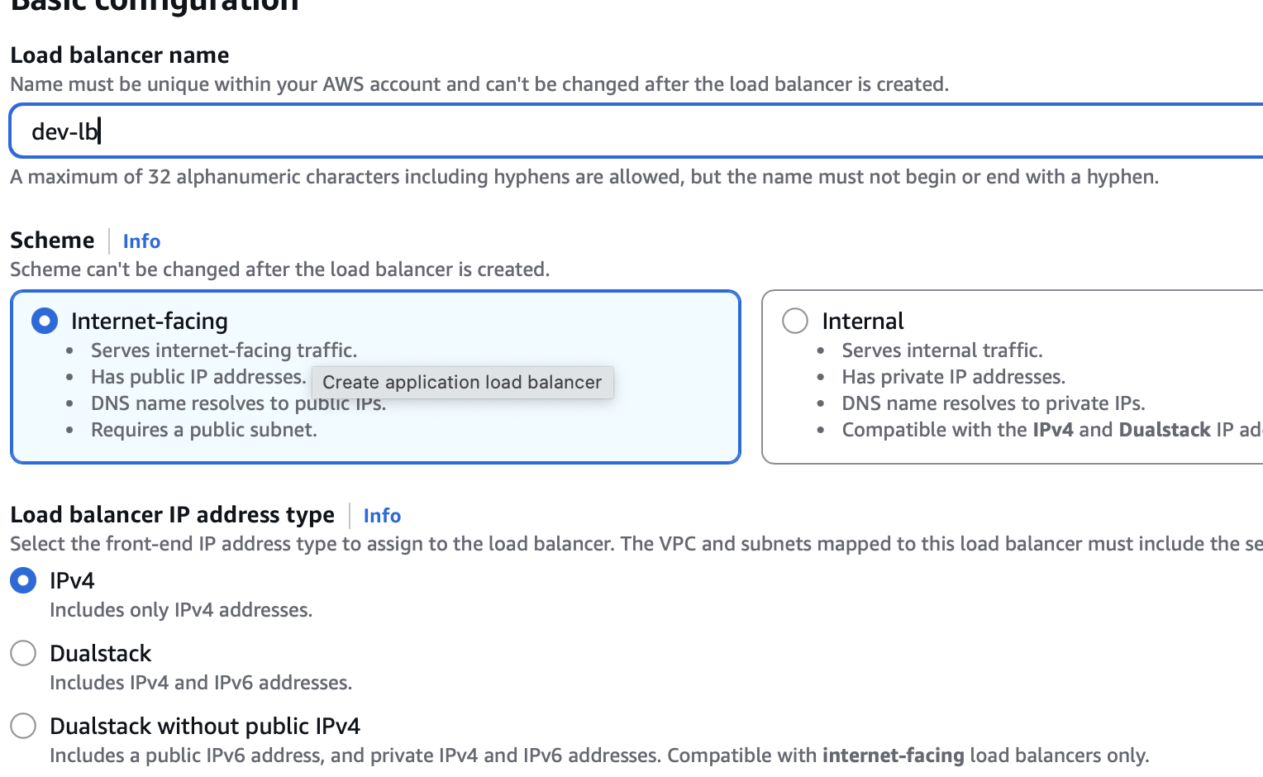
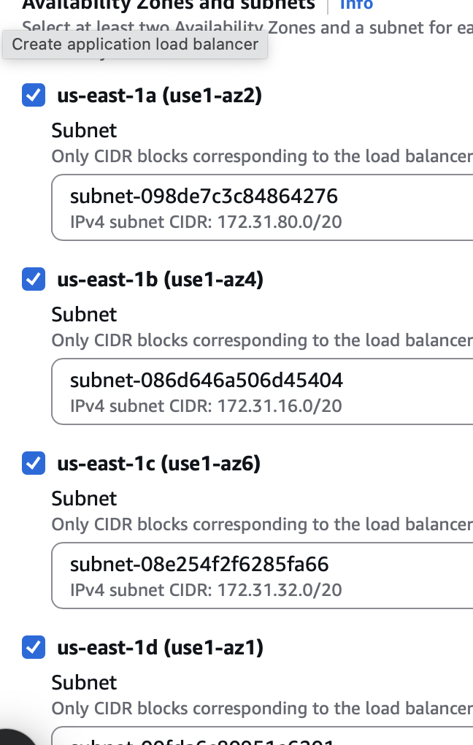

Create a new security goup with all traffic enabled
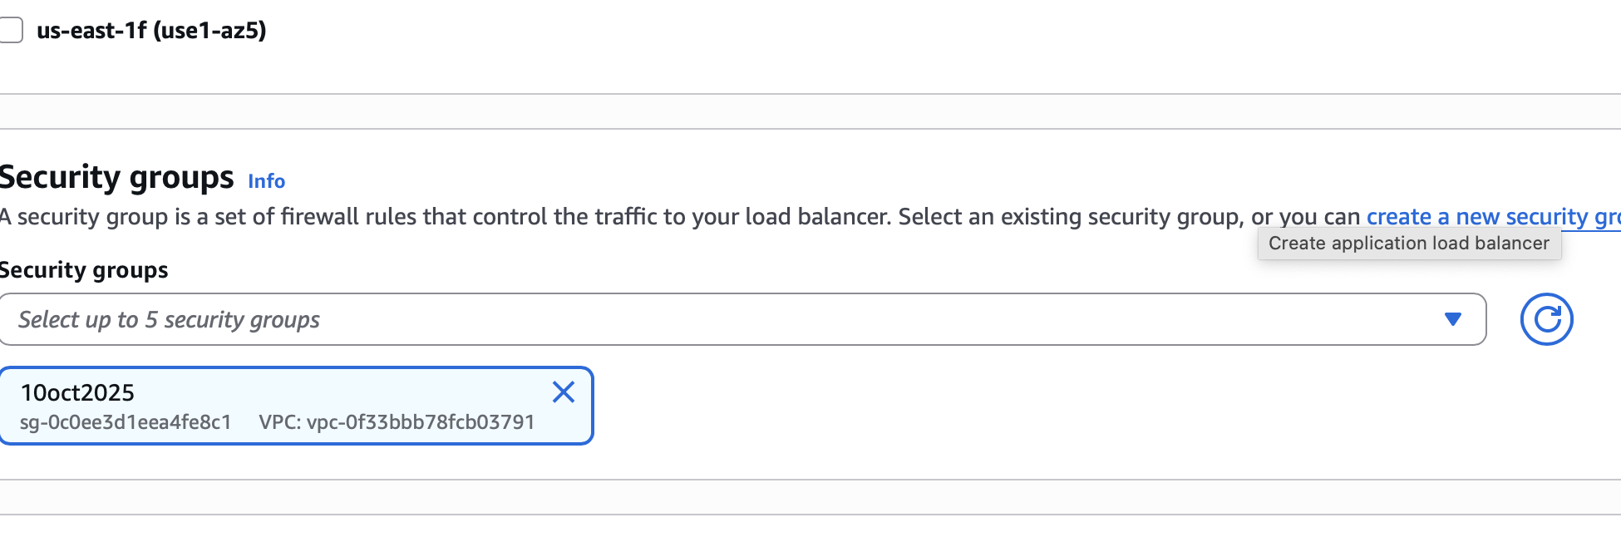

Although my container is working on port 8080
I am configuring the loadbalancer to listen on port 80
Lets say traffic will come on 80 of lb and will be pointed to 8080 of the container

Listner : 80

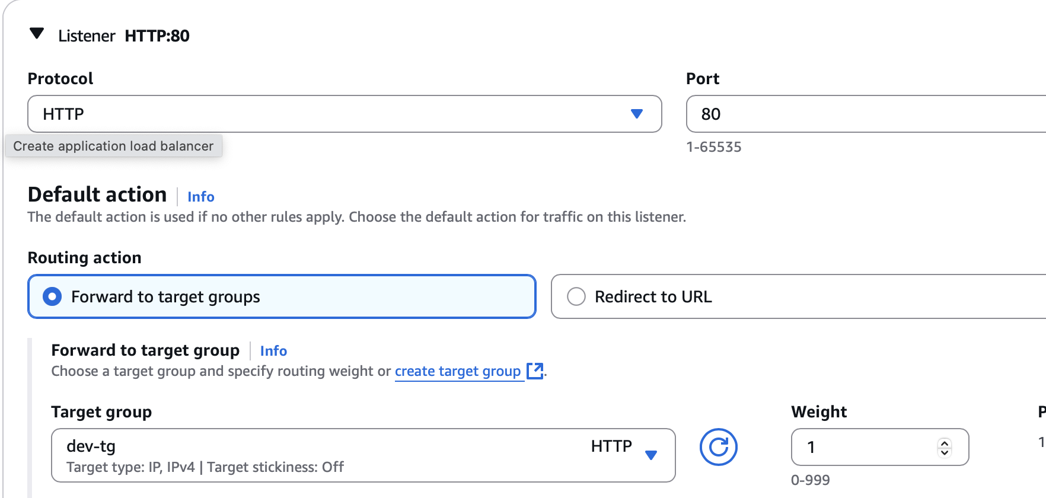

Create lb

Go to ecs - cluster
Create service

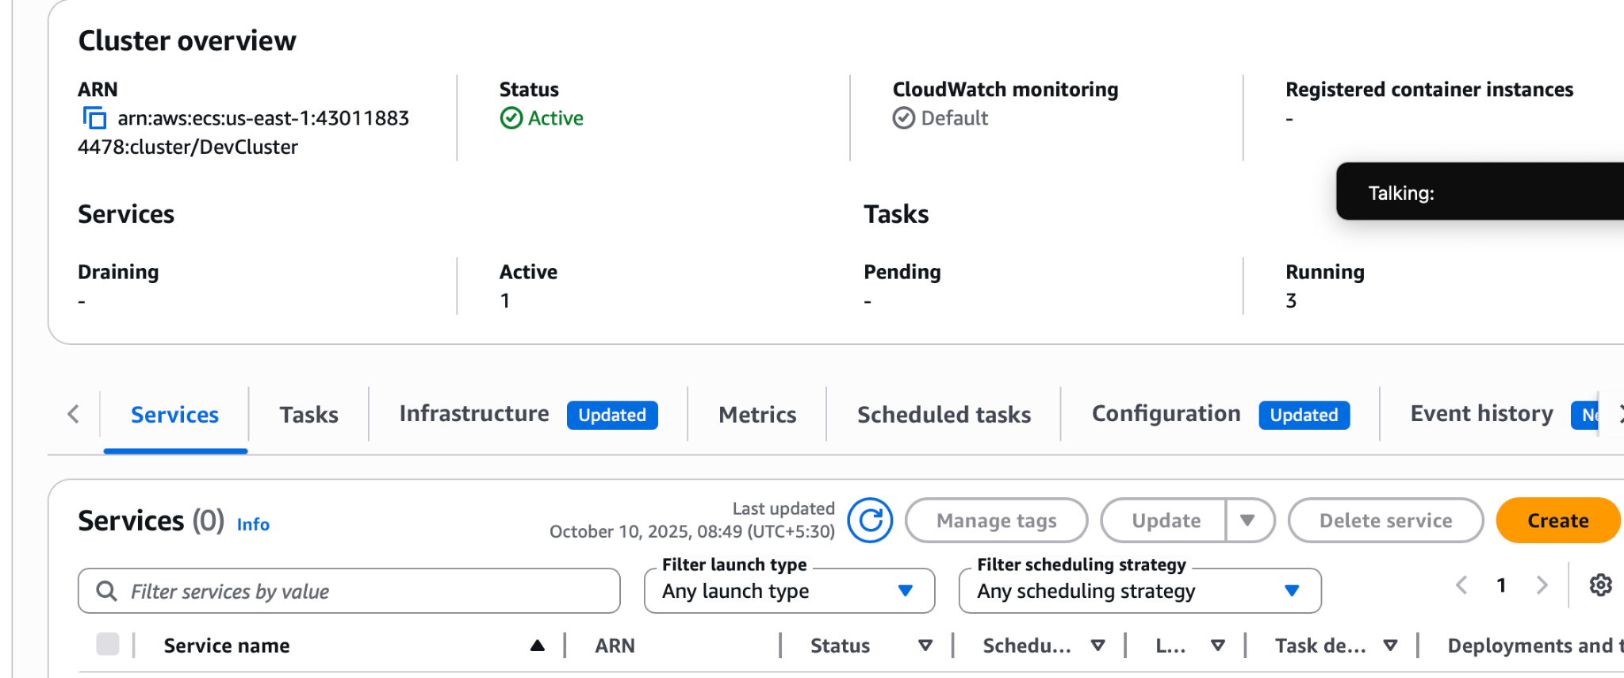

Create service

Select task definition
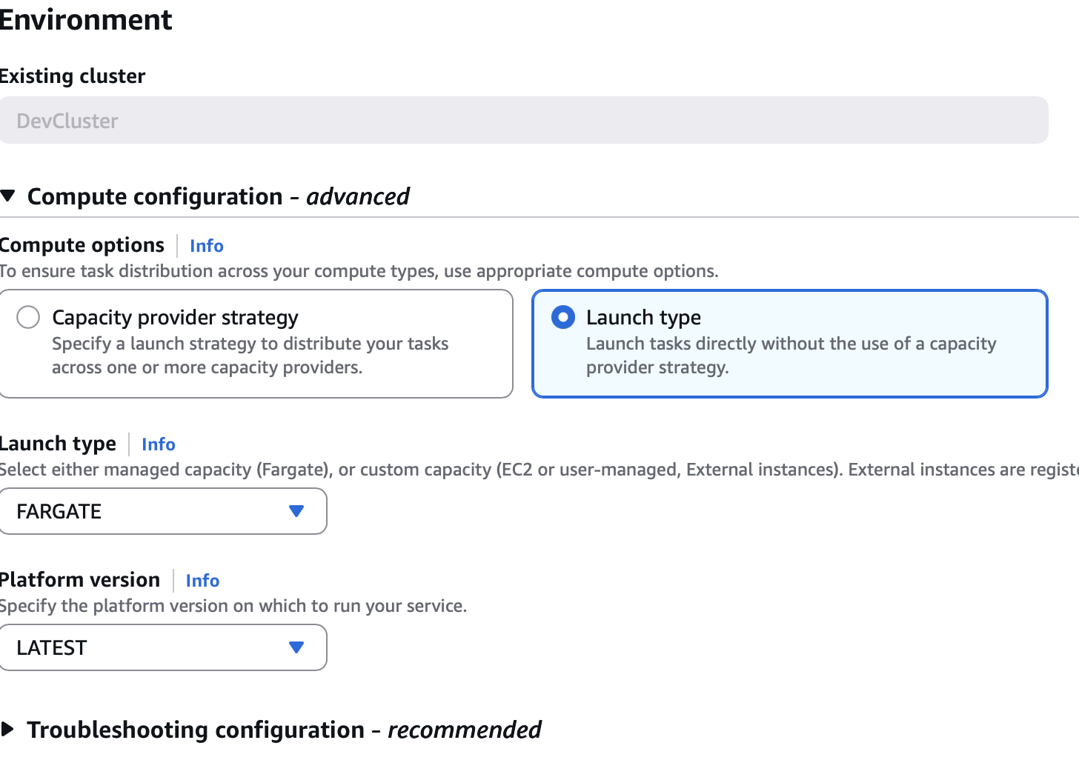

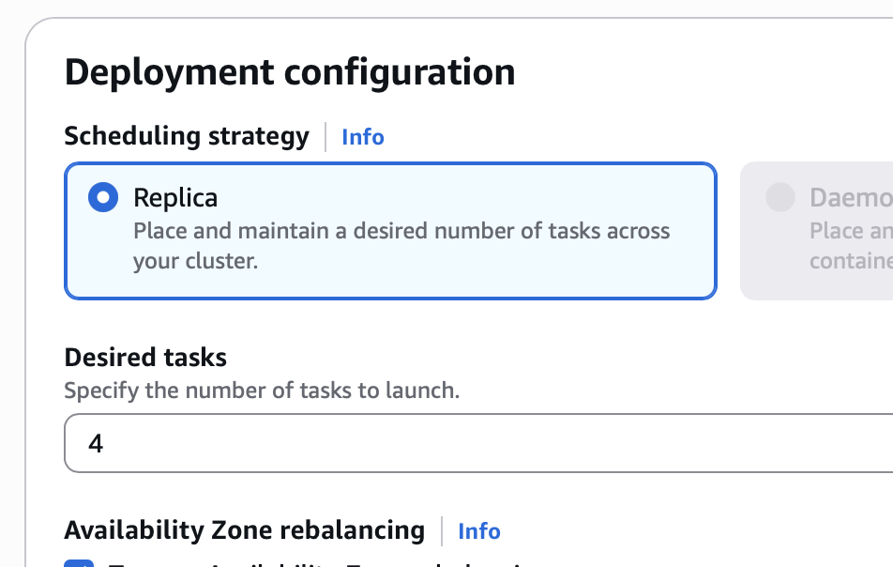
In networking
Select the sg with all traffic enabled
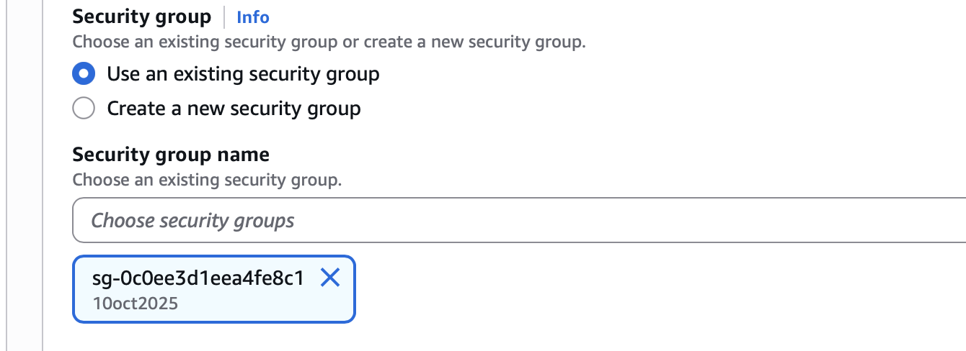
In load balancing
Tick use load balancer
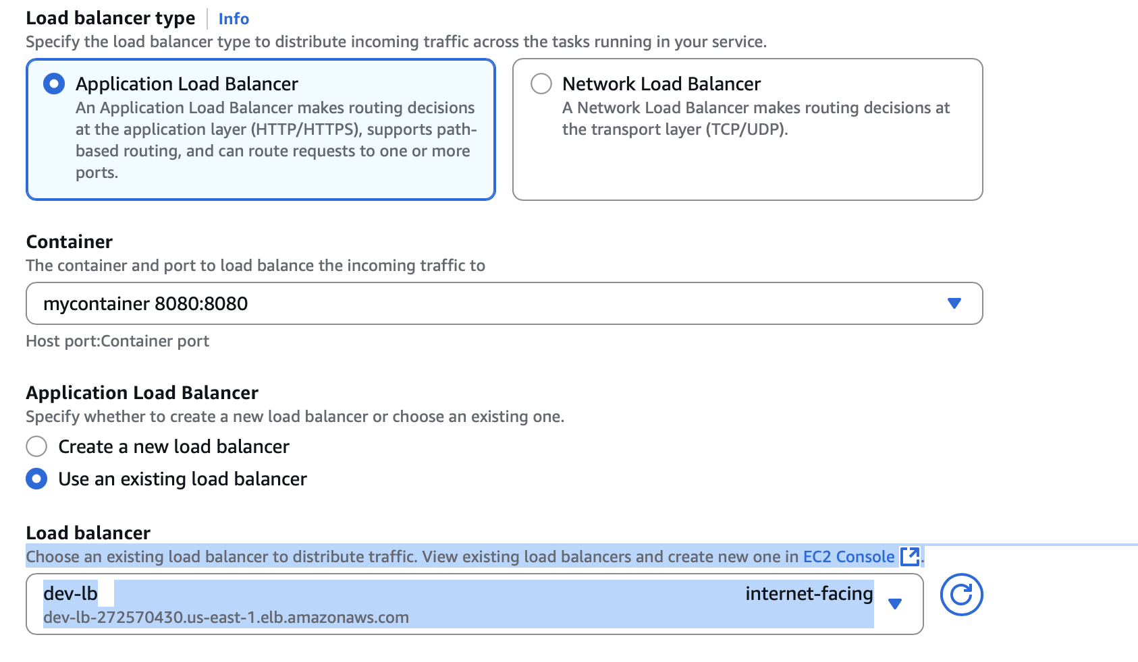

Since my lb will listen to port 80
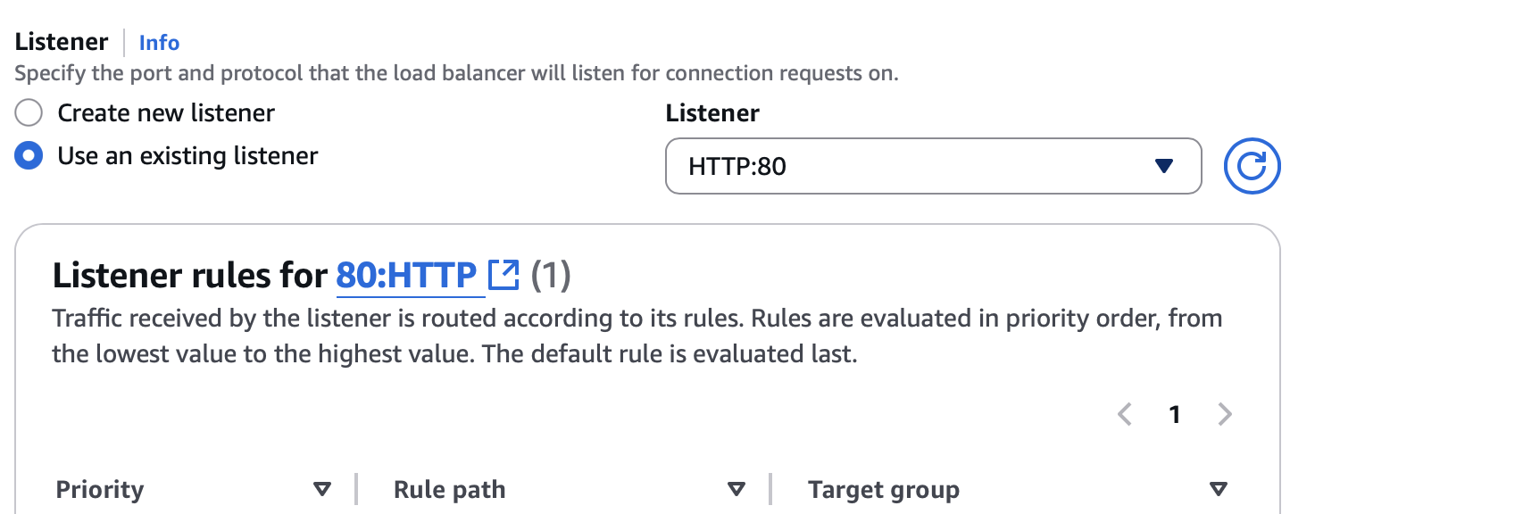
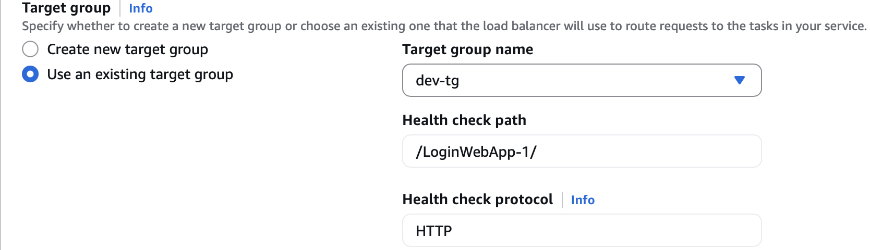
Create

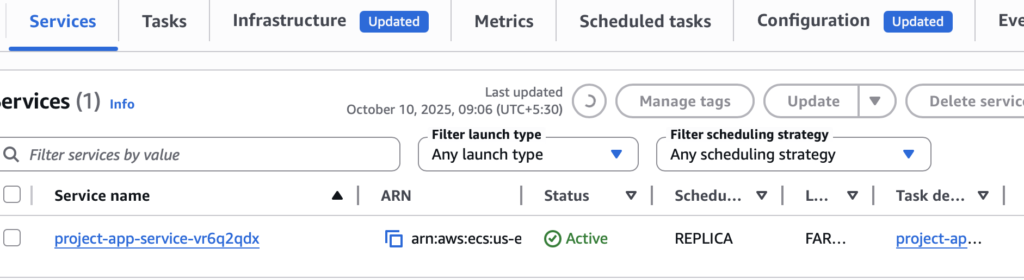

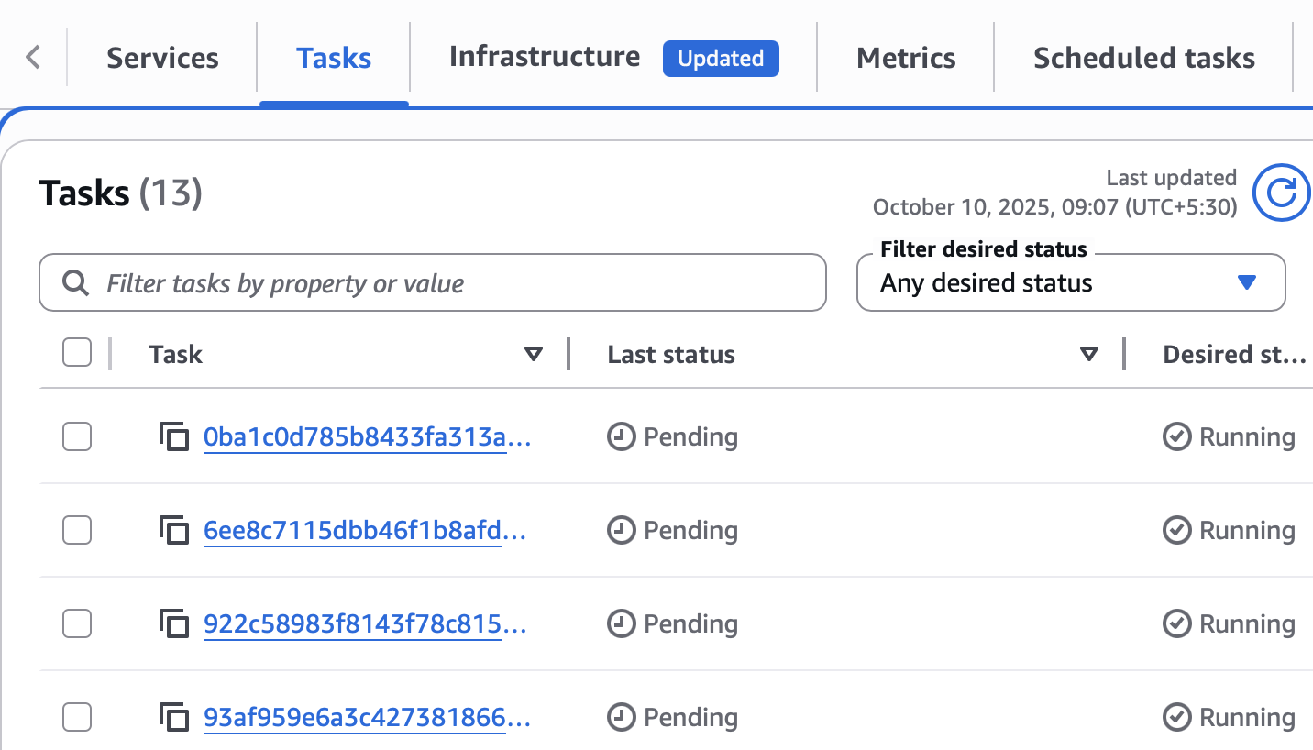

Wait for them to run

Go to load balancer and copy the dns
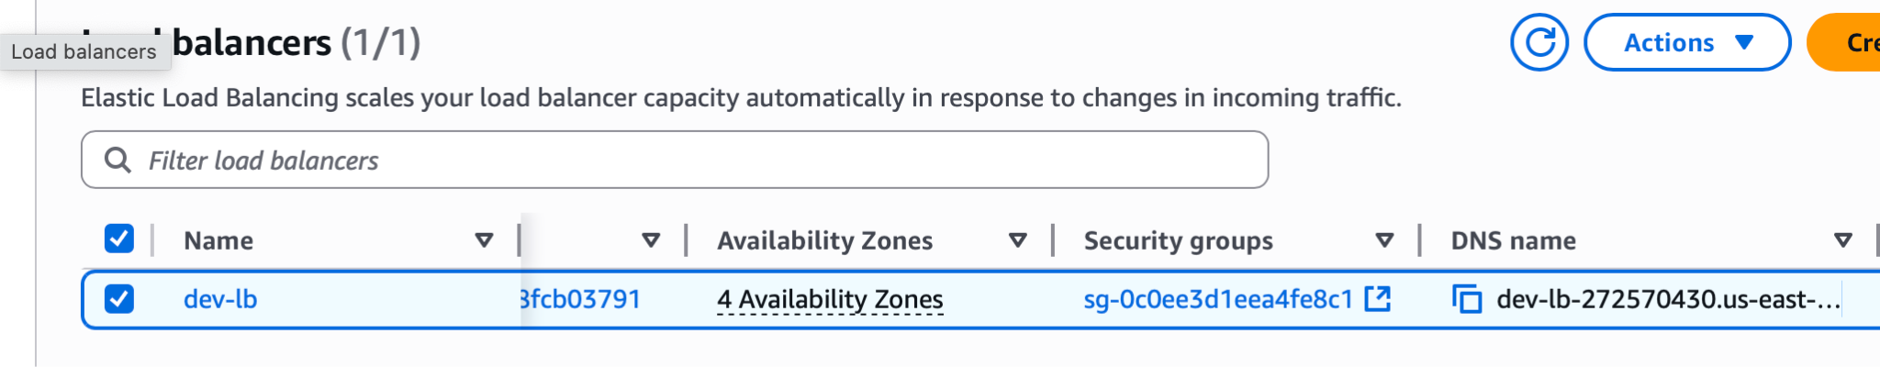

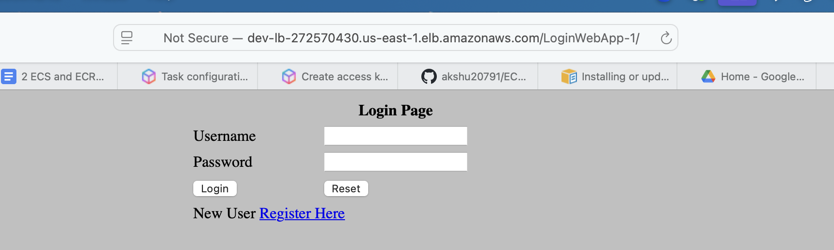

Sample example link: http://dev-lb-272570430.us-east-1.elb.amazonaws.com/LoginWebApp-1/

